Navodilo za TJA 9.ab - SRE 8. 4.

- Za začetek preglej vaje v DZ 93+94/2ab, 3a.

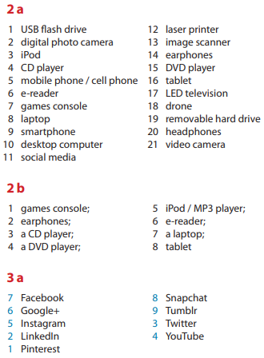

- Današnjo uro nameniš branju besedila o enem izmed novejših načinov komuniciranja.

Preberi besedilo, ki ga najdeš na povezavi https://www.liveworksheets.com/oa16057sv .

Besedilo ni najbolj enostavno, zato si vzemi čas:
- prvič ga preberi bolj na hitro, tako da samo vidiš približno vsebino odstavka
- drugič ga preberi zelo počasi, tako da poskušaš dojeti bistvo vsakega stavka posebej (pazi: bistvo, torej glavno informacijo stavka, ne pa prevod)
- tretjič ga beri tako, da zraven iščeš in pišeš odgovore na vprašanja

- V mail prilepi spodnja vprašanja in odgovori nanje (do TOR 14. 3.). Yes, in English

- Par. 1: What do you think who are “digital natives”? Are you and your friends “digital natives” or “digital migrants”? What about your parents or your teachers?
- Par. 1: Which social media platforms are mentioned in the first paragraph?
- Par. 2: How many people use social networks these days?
- Par. 2: How many FB friends does your generation make per week if you consider the statistics?
- Par. 2: How many people used FB in 2009? What about in 2015?
- Par. 3: Which British prefer FB to other social networks?
- Par. 4: Name 4 reasons teenagers and young adults use social media for.
- Par. 5: According to the text social media addiction “threatens your real-life communication skills”. How do you understand this sentence, what does it mean?
- Par. 5: Addiction to social media might have a bad influence on your grades. Copy the sentence from the text which proves that.

