**PETEK, 27. 3. 2020**

TJA 7

Danes ti pošiljam **rešitve preverjanja**. Če preverjanja še nisi rešil(a), ga najprej dokončaj, šele potem preveri rešitve. Ne pozabi na anketo, ki sem jo poslala včeraj.

Napisal(a) pa boš še **sestavek**. V mojem e-nabiralniku ga pričakujem do **torka, 31. 3. 2020, do 19. ure**. Prosim, da se držite roka in da opravite svojo nalogo, ker beležim vaše delo. Sestavek NUJNO podpišite. Lahko ga natipkate in pošljete ali pa napišete v zvezek in mi pošljete fotografijo.

Želim vam lep vikend 😊!

**Pisni sestavek - navodilo**

**Oglej si Tinine zapiske o prejšnjem tednu. V njen dnevnik napiši, kaj je delala. Izmisli si nekaj podrobnosti, da bo besedilo bolj zabavno.**

**Piši v PRETEKLIKU (The Past Simple Tense).**

**Monday go to the shops, play with the hamster**

**Tuesday have a Maths test (easy)**

**Wednesday watch a pop concert on TV, write a letter to my penfriend**

**Thursday buy a present for David` s birthday**

**Friday not meet up with some friends, study English**

**Saturday David`s birthday party, dance, sing & have a great time**

**Sunday visit Grandma, play the piano**

**Dear diary, …**

**FINAL REVISION on the Past Simple Tense - REŠITVE**

Name: ____________________ Class: 7. _____ Date: March, 2020

**1. Dopolni tabelo.**

|  |  |  |
| --- | --- | --- |
| **POSITIVE (trdilna oblika)** | **NEGATIVE (nikalna oblika)** | **QUESTION (vprašalnica)** |
| She was ill yesterday. | She wasn't ill yesterday. | Was she ill yesterday? |
| Glagol BITI v pretekliku. | | |
| You had a toothache. | You didn't have a toothache. | Did you have a toothache? |
| Glogol IMETI v pretekliku. | | |
| They flew to the USA last month. | They didn't fly to the USA last month. | Did they fly to the USA last month? |
| NEPRAVILNI GLAGOL (fly -flew) | | |
| He studied very hard. | He didn't study very hard. | Did he study very hard? |
| PRAVILNI GLAGOL (study – studied – pazi le na zapis!) | | |

**2. Dopolni sestavek z was ali were.**

**Rush hour**

The day before yesterday I was on a bus going to Piccadily Circus. It **WAS** the rush hour and the bus **WAS** very crowded. There **WAS** a fat woman with her three fat children. There **WAS** a thin man with his two thin children. There **WAS** a man with a big dog and a woman with a little dog. There **WERE** people with bags and people with umbrellas. There **WERE** people upstairs and people downstairs. There **WAS** no seat for me. I hate rush hours.

Zapomni si:

WAS + EDNINA

WERE + MNOŽINA

**3. Poveži vprašanja s pravilnimi odgovori.**

|  |  |  |  |
| --- | --- | --- | --- |
| 1 | What was your favourite toy? | **4** | No, they didn't. |
| 2 | Was your hair long when you were a baby? | **6** | It was rainy. |
| 3 | What time were you born? | **7** | Miss Green. |
| 4 | Did they have fridges sixty years ago? | **2** | No, it was short. |
| 5 | Where were you yesterday? | **8** | Green. |
| 6 | What was the weather like? | **5** | At home. |
| 7 | Who was your class teacher in the first form? | **1** | A teddy bear. |
| 8 | What colour were your eyes? | **3** | At 8 pm. |

**4. Obkroži pravilni odgovor.**

* What colour _________ your eyes when you were a baby?

|  |  |  |  |
| --- | --- | --- | --- |
| A was | B blue | C were | D are |

* Roald Amundsen travelled to the South Pole. He __________ travel to the North Pole.

|  |  |  |  |
| --- | --- | --- | --- |
| A didn't | B isn't | C wasn't | D weren't |

* __________ those days they washed their clothes by hand.

|  |  |  |  |
| --- | --- | --- | --- |
| A by | B at | C on | D in |

* Leon Štukelj lived __________ 1898 to 1999. **Nobena rešitev ni prava. Pravilna rešitev je from.**

|  |  |  |  |
| --- | --- | --- | --- |
| A and | B to | C between | D in |

* __________ knighted Charlie Chaplin? – Queen Elizabeth.

|  |  |  |  |
| --- | --- | --- | --- |
| A How | B Who | C When | D Why |

* __________ the age of 22, she moved to England.

|  |  |  |  |
| --- | --- | --- | --- |
| A by | B for | C to | D at |

**5. Povedi postavi v navadni sedanjik ali navadni preteklik. Pazi na časovne izraze.**

|  |  |
| --- | --- |
| **THE PRESENT SIMPLE TENSE** | **THE PAST SIMPLE TENSE** |
| The weather **is** very nice this week. | The weather **was** nice last week. |
| They **travel** to the USA. | They **travelled** to the USA. |
| She **has (got)** a cat, | She **had** a cat. |
| My father **sells** cars. | My father **sold** cars. |
| He **feels** great today. | He **felt** great yesterday. |
| Navadni sedanjik:  SHE/HE/IT + glagol s končnico -s! |  |

**6. Dopolni povedi. Prva črka besede je že zapisana.**

Queen Vicoria ruled in Britain in the 19th CENTURY.

Mozart was an Austrian composer and Prešeren was a Slovene POET.

Walter believes that he is BETTER off than his grandfather.

Sixty years ago people had a PANTRY instead of a fridge.

Charlie´s films were first SILENT and later SOUND.

Besedišče iz besedil:

Who was who?

Then and now

The king of comedy: Sir Charlie Chaplin

**7. Izberi ustrezno besedo iz okvirčka. Dve besedi sta odveč.**

|  |
| --- |
| **at difficult** Besedi sta odveč. |

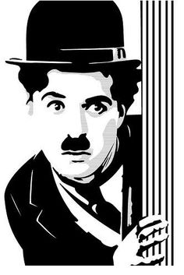***Sir Charlie Chaplin, a famous English comedian, director and PRODUCER was born in 1889 in London. His childhood wasn’t EASY because his parents weren’t well off. The situation became even worse when his father died. Charlie had to live IN a children’s home. Life was hard there, but he always BELIEVED in himself.***

***He started his film CAREER in America. By earning a lot of money he could form his own film-making COMPANY. He played the role of a TRAMP in more than seventy films. He had black hair, a moustache and was dressed in BLACK. He usually carried a walking stick. He RECEIVED an Oscar, an American film award in 1972. Chaplin died ON Christmas day, in December 1977***.

**8. Form questions.**

(Tvori vprašanja.)

Pri tej nalogi je več možnih odgovorov. Če nisi prepričan(a) v svojo rešitev, mi piši.

Did they (poor people/all people) have televisions?

No, they didn't. Only rich people had televisions in those days.

Did the Panama canal open in 1930? ali When did the Panama canal open? ali What opened in 1930?

The Panama canal opened in 1930.

Was Madonna born on 16th August, 1958? ali When was Madonna born? Ali Who was born on 16th August, 1958?

Madonna was born on 16th August, 1958.

Did she come to school yesterday? ali vsako smiselno vprašanje z Did…?

No, she didn't. She was at home because she was ill.

Did my brother break a vase? ali What did my brother break? ali Who broke a vase?

My brother broke a vase.

**9. Natančno preberi besedilo v prilogi in reši spodnje naloge.**

**A) Ali trditve držijo ali ne? Označi pravilen odgovor. Napačne trditve popravi.**

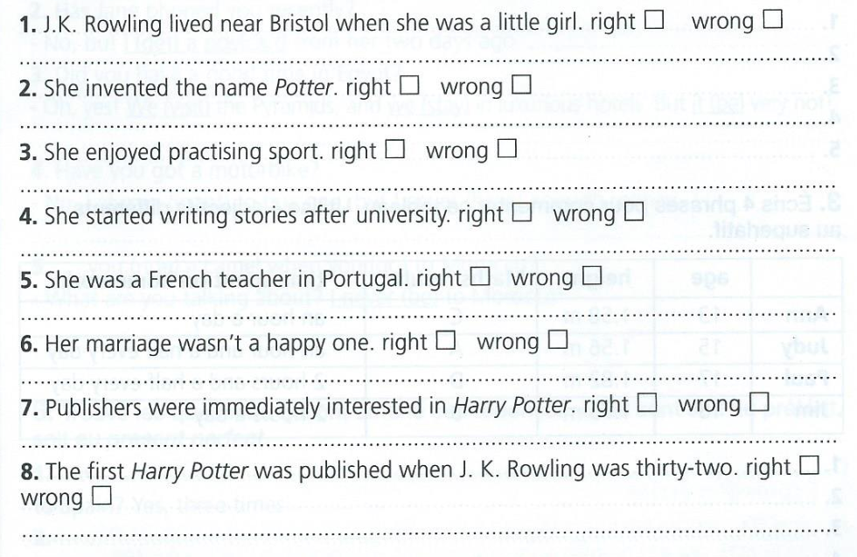

REŠITVE:

1. Right
2. Wrong. (Two of her friends were called Potter.)
3. Wrong. (She wasn’t good at sports.)
4. Wrong. (She started writing stories when she was out of work / when she didn’t have a job.)
5. Wrong. (She was an English teacher in Portugal.)
6. Right.
7. Wrong. (Many publishers rejected / didn’t like Harry Potter.)
8. Right.

**B) V besedilu izpiši 5 nepravilnih glagolov in dopolni tabelo. Glej primer, ki je že rešen.**

**Imaš več možnosti:**

|  |  |  |
| --- | --- | --- |
| **NEDOLOČNIK** | **PRETEKLIK** | **PREVOD** |
| *BE* | WAS | *biti* |
| spend | spent | preživeti, zapraviti |
| write | wrote | (na)pisati |
| have | had | imeti |
| go | went | iti |
| come | came | priti |
| send | sent | poslati |
| buy | bought | kupiti |
| become | became | postati |

**C) Tri glagole iz razpredelnici uporabi v svojih povedih. Povedi naj bodo v pretekliku.**

Po smislu. Lahko mi jih pošlješ na [barbara.ahacic@oskoroskabela.si](mailto:barbara.ahacic@oskoroskabela.si).

Npr:

He wrote a letter yesterday.

They had a record player.

My mum bought a new dress.



JOANNE KATHLEEN ROWLING



