**PETEK, 17. 4. 2020**

TJA 7. A

Najprej preglej nalogo:

1. **UČ** str. 98/3

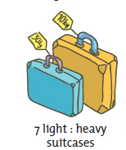 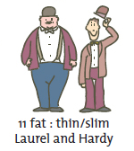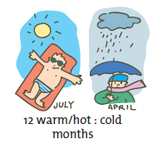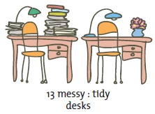

The blue suitcase is **heavier than** the yellow suitcase.

The yellow suitcase is **lighter than** the blue suitcase.

Hardy (Oliver) is **fatter than** Laurel (Stan).

Laurel is **thinner/slimmer than** Hardy.

July is **warmer/hotter than** April.

April is **colder than** July.

The left desk is **messier than** the right desk.

The right desk is **tidier than** the left desk.

2. **DZ** str. 104/7b, str. 106/10, str. 107/12

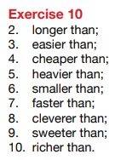* Naloga DZ str.104/7c je za radovedne.

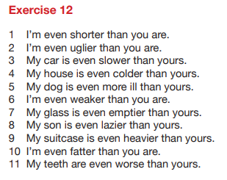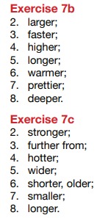

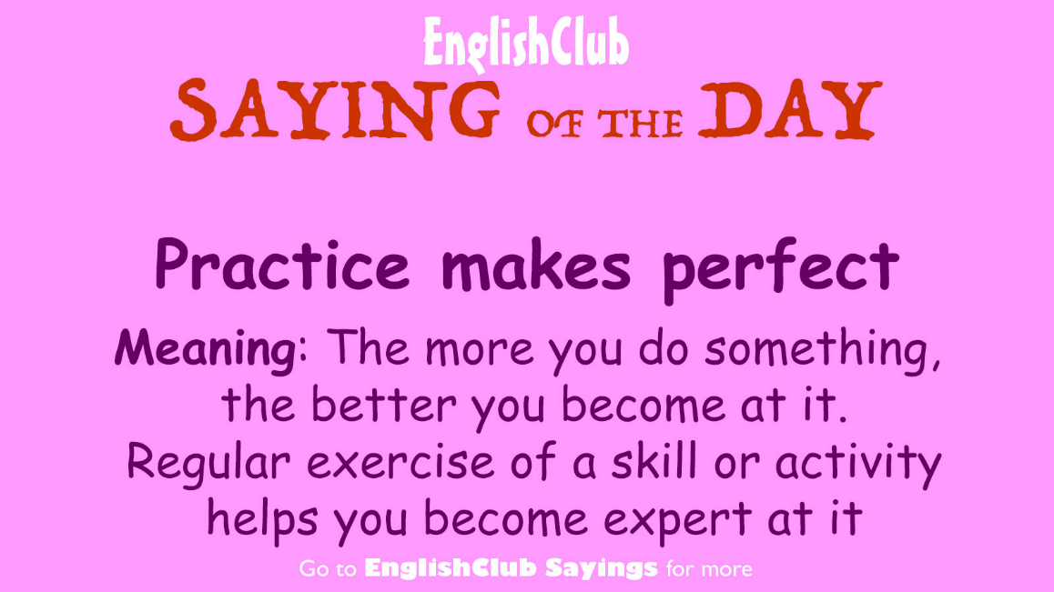

Mislim, da s stopnjevanjem kratkih pridevnikov nimate težav. Ker pa vaja dela mojstra (Practice makes perfect.), bomo danes še malo vadili. Naslov v zvezku je še vedno **Exercise**.

**1. UČBENIK**

UČ str. 101/4

Ustno naredi vse primere, v zvezek pa zapiši tri, ki jih izbereš sam(a). Za vsak primer napiši tri povedi.

Primer:

Triglav is high. / Mont Blanc is higher than Triglav. / Mount Everest is the highest.

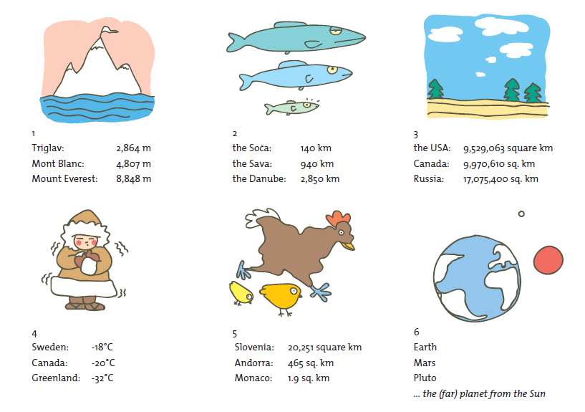

**2. UČNI LIST**

Če imaš možnost, učni list lahko natisneš in ga rešiš.

Če te možnosti nimaš, v zvezek napiši samo rešitve.

SHORT ADJECTIVES – MAKING COMPARISONS

**1. Dopolni drugo poved tako, da ne spremeniš pomena prve povedi.**

1. Tim is older than Sarah. (young)

Sarah is ________________________________________________________.

1. Our house is larger than yours. (small)

Your house is ____________________________________________________.

1. Bill is taller than David. (short)

David is ________________________________________________________.

1. Jack’s marks are worse than mine. (good)

My marks _________________________________________________ Jack’s.

1. Your bike is slower than mine. (fast)

My bike ________________________________________________________.

**2. Dopolni povedi tako da vstaviš *predlog the+presežnik*.**

1. Who’s ______________ (good) footballer in Europe?
2. This was ______________ (cheap) watch that they had in the shop.
3. The blue whale is ______________ (large) of all the animals.
4. ______________ (old) university in the world is in Morocco.
5. I think that was one of ______________ (bad) days of my life.

**3. Pridevnike v oklepaju postavi v ustrezno obliko.**

1. Ben is a ______________ boy. He’s ______________ than Tony. He’s ______________ boy in his class. (tall)
2. Mandy is a ______________ pupil. She’s ______________ pupil in our class. She’s much ______________ than Jane. (good)
3. Is John a ______________ football player? Yes, he’s ______________ player in our team. He’s even ______________ than little Bobby. (bad)
4. New York is a ______________ city. It’s ______________ city in the USA. (big)
5. Storžič is a ______________ mountain, but Triglav is ______________ in Slovenia. (high)
6. Is the Soča ______________ than the Sava? (long)
7. Which is ______________ month in the year? (short)
8. This year the weather is ______________ than last year. (bad)
9. Wine is ______________ in Slovenia than in GB. (cheap)
10. He thinks he’s ______________ pupil in the class. (good)
11. There are ______________ shops in London than in other towns. (good)
12. Bananas are ______________ than oranges. (sweet)
13. This is ______________ story in the book. (short)
14. Paul’s homework is ______________ of all. (bad)

