**[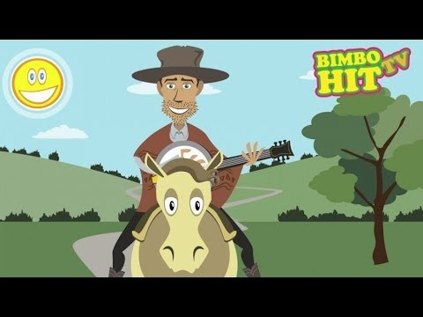](https://www.youtube.com/embed/1aT2mL7k8bQ?feature=oembed)PETEK, 8. 5. 2020**

Za začetek poslušaj eno od tradicionalnih ameriških pesmi.

TJA 7. A

Rešitve kviza:

1. C; 2. B; 3. A; 4. B; 5. C; 6. A; 7. B; 8. C; 9. C; 10. B

Povedi:

1. The USA is the fourth largest country in the world.
2. The USA has got 50 states./ There are 50 sates in the USA.
3. The capital of the USA is Washington, DC.
4. The President lives and works in the White House.
5. New York is the biggest city in the USA.
6. Hollywood is in LA (Los Angeles).
7. The official language is English.
8. The second most common language is Spanish.
9. The most popular sport is baseball.
10. America declared independence on the 4th of July.



Še enkrat poslušaj besedilo o ZDA.

<https://touchstone.si/audio/ts7/105_The_United_States_of_America.mp3>

Prepiši vprašanja in napiši odgovore. Odgovori naj bodo **kratki**.

1. Is the USA the largest country in the world?
2. Is it poor?
3. How many states are there in the USA?
4. What`s the capital?
5. Where does the President work and live?
6. Who`s the current president of the USA?
7. Name some most important cities!
8. What`s Hollywood?
9. Why is it very Spanish in character?
10. What`s the official language?
11. What`s the most common language beside English?
12. What`s the most popular sport?
13. The most important American holiday?
14. Why is the USA so attractive and interesting?
15. Who were the first inhabitants?
16. Where did the immigrants come from?
17. Where did the black people come from?
18. What were they?

