SREDA, 22. 4. 2020
TJA 8 (skupina Ahačič: Anan, Ana, Matic, Gaj, Ermin, Kristjan, Anja, Ema, Matija, Jaka, Eldar, Anel)

Vstopamo v nov teden in pred nami so nove naloge in novi izzivi.
Verjamem, da se jih veselite !
Za začetek naj vas zbudi pesmica za sredo…

… potem pa preverite rešitve petkove naloge:
Pedro Sombrero is the chubby boss of the Mexican Mafia. Pedro has a gold tooth. Everyone can see it when he laughs. He wears a moustache. His face is fat and he has a huge double chin. He always wears a sombrero hat.

Pete Baldy is a computer hacker. The police wants him for hacking into the Pentagon’s web server. Peter shaves his head every two days. That’s why his nickname is Baldy. He wears black-rimmed glasses. He always wears a sleeveless shirt.

Sen Cypress is a drug pusher in Los Angeles. He wears a white baseball cap sideways. He wears a moustache and a goatie beard. He has huge eyes and a mean look. His nose is small.

Po počitnicah začenjamo z ocenjevanjem. O ocenjevanju pri pouku TJA se bomo pogovorili na ČETRTKOVI videokonferenci (Zoom).
Datum: ČETRTEK, 23. 4. 2020
Ura: 11.00
Povezava: https://us04web.zoom.us/j/74074314105
Meeting ID: 740 7431 4105
Udeležba je OBVEZNA!
Pred nami je novo poglavje Unit 3: Away from home.

1. Za uvod v poglavje boste naredili nalogi v delovnem zvezku:
DZ str. 97/1,2

2. Nadaljujemo pa z uvodnim pogovorom v učbeniku.

DAILY CHORES (Hišna opravila) (naslov v zvezku)

Danes bomo spoznali Nicoletto Rossi, ki dela kot varuška (au pair) pri družini Harrison. Tam pomaga tudi pri hišnih opravilih in se hkrati uči angleško.
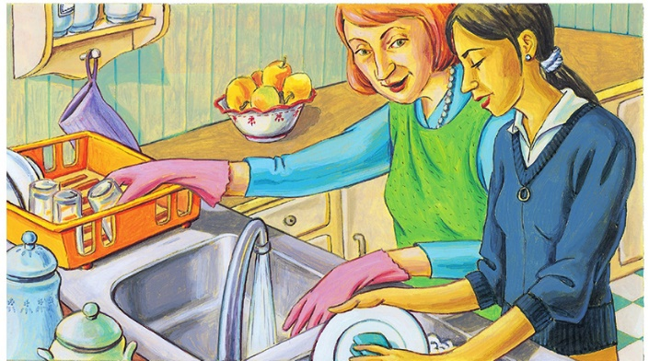

UČ str. 102/1
Poslušaj pogovor https://touchstone.si/audio/ts8/102_Daily_chores.mp3
Preberi pogovor.

UČ str. 102/2
Preberi povzetek pogovora. Poišči napake. Povzetek brez napak napiši v zvezek.

