SREDA, 18. 3. 2020

TJA 8 (skupina Ahačič: Anan, Ana, Matic, Gaj, Ermin, Kristjan, Anja, Ema, Matija, Jaka, Eldar, Anel)
Dragi osmošolci!
Od 16. do 27. marca bo naše delo potekalo na daljavo. Verjamem, da boste k delu pristopili odgovorno in boste svoje zadolžitve pravočasno opravili. Ker v 8. razredu učim dve skupini, vedno preverite, če ste odprli pravo priponko.
Če boste imeli pri delu težave, mi pišite na moj naslov barbara.ahacic@oskoroskabela.si.
Ostanite zdravi in se tipkamo!
Učiteljica Barbara

SUBJECT & OBJECT QUESTIONS
Naslednji dve uri bomo utrjevali vprašalnice; predvsem tiste za osebek in predmet.

Najprej rešitve domače naloge (preveri, popravi):
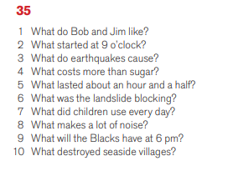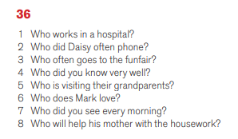

Vaša današnja naloga je učni list. Učnega lista ne tiskaš, rešitve zapišeš v zvezek. Naslov v zvezku je Exercise (Vaja). Rešitve dobiš jutri.

SUBJECT AND OBJECT QUESTIONS - EXERCISES
1. Podčrtaj osebek (SUBJECT). Tvori vprašalnico za osebek. Glej primer, ki je že rešen.
1. My friend broke the window.  2. They came with my mother.  3. Mike wanted to see you.  4. You told me about the accident.  5. Everything went wrong.  6. Mary read that book last year.  7. We met George last night.  8. I phoned the headmaster. | WHO broke the window?  __________________________________________  __________________________________________  __________________________________________  __________________________________________  __________________________________________  __________________________________________  __________________________________________

2. Podčrtaj predmet (OBJECT). Tvori vprašalnico za predmet. Glej primer, ki je že rešen.
1. My friend broke the window.  2. They came with my mother.  3. Mike wanted to see you.  4. You told me about the accident.  5. James bought new car yesterday.  6. Mary read that book last year.  7. We met George last night.  8. I phoned the headmaster. | WHAT did my friend break?  __________________________________________  __________________________________________  __________________________________________  __________________________________________  __________________________________________  __________________________________________  __________________________________________

Na naslednji strani imaš razlago za pomoč. Razlage ne prepisuješ, saj jo imaš že v zvezku.

SUBJECT AND OBJECT QUESTIONS

ZAPOMNI SI:
WHO? = KDO? (za ljudi)
WHAT? = KAJ? (za vse ostalo)
SUBJECT (S) = OSEBEK
OBJECT (O) = PREDMET

A) VPRAŠALNICE ZA OSEBEK
W H O ? | W H A T ?
Mary likes cats. | The shop opens at 8 am.
WHO likes cats? | WHAT opens at 8 am?
We like cats. | Cats drink milk.
WHO likes cats? | WHAT drinks milk?
Mary is my friend. | Our car is fast.
WHO is my friend? | WHAT is fast?
They are happy. | Dogs are beautiful.
WHO is happy? | WHAT is beautiful?

Vprašalnica za osebek:

WHO/WHAT + glagol v ednini

B) VPRAŠALNICE ZA PREDMET
W H O ? | W H A T ?
She likes John. | He likes fast cars.
WHO does she like? | WHAT does he like?
We love our parents. | They love music.
WHO do we love? | WHAT do they love?

Vprašalnica za predmet:

WHO/WHAT + pomožni glagol + osebek + glagol

