Navodilo za delo – TJA 8, SRE 20. 5.

- Preglej vaje DZ 107/ 18ab+19.
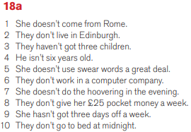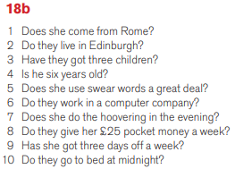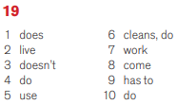

- K včerajšnji snovi (Present Simple) dopiši spodnja opozorila:

POGOSTI PRISLOVI
always, regularly, often, sometimes, seldom, rarely, never, every (Friday), in (January, summer), on (Friday), at (five o'clock),

POSEBNE OBLIKE
“be” AM, IS, ARE
»have got” HAVE GOT, HAS GOT

POSEBNOSTI PRI PISAVI
- če se glagol konča na –s, -sh, -ch, -x, -zz, dodamo glagolu končnico –es:

they pass – he passes
I wash – she washes
you watch – it watches
I box – he boxes
we do – he does
I buzz – it buzzes

- če se glagol konča na soglasnik + –y, glagol dobi končnico - ies:

c r y - cries

soglasnik + y

- glagoli DO, GO, HAVE:

do – does
go – goes
have – has
- Preberi Remember box v DZ 108 (zelen okvirček spodaj).

- Reši vaji DZ 108+109/20+21.

- Reši vaji na spletu. Na koncu klikni Check Answers, da vidiš, kako uspešen si bil.
https://www.ego4u.com/en/cram-up/grammar/simple-present/form/exercises?04
https://www.ego4u.com/en/cram-up/grammar/simple-present/form/exercises?05

