Navodilo za delo – TJA 8, SRE 15. 4.

- Preglej / dopolni vaji, ki si ju včeraj prepisal z UL (rešitve so spodaj).

- V zvezek ni treba novega naslova, zapiši samo datum 15. 4., in vprašanja iz okvirčka.

What are you wearing? = Kaj imaš oblečeno?

What do you look like? = Kako izgledaš?

What are you like? = Kakšen si (po značaju)?

What do you like? = Kaj ti je všeč?

- Reši DZ 80/48.

- Reši vaje Activity 1, 2, 3.

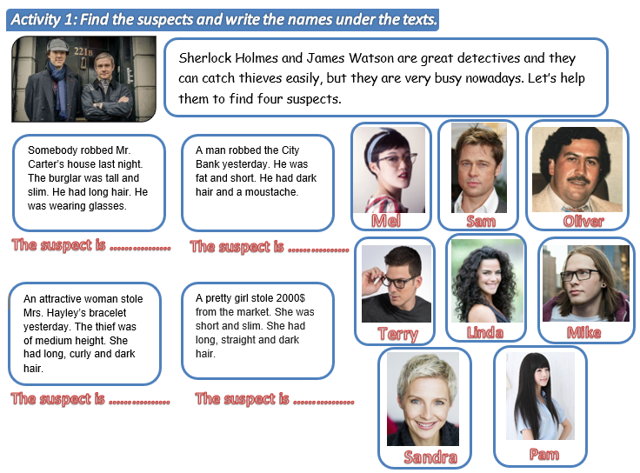
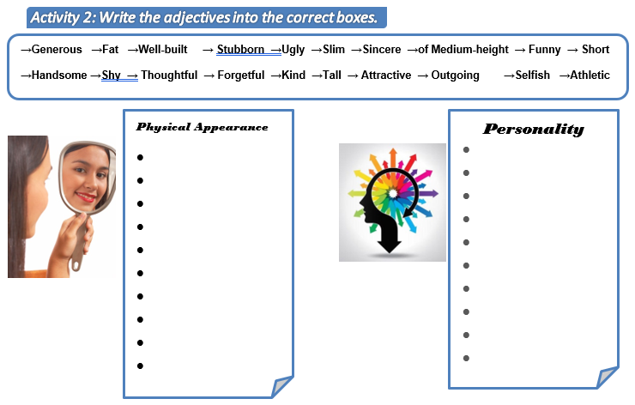
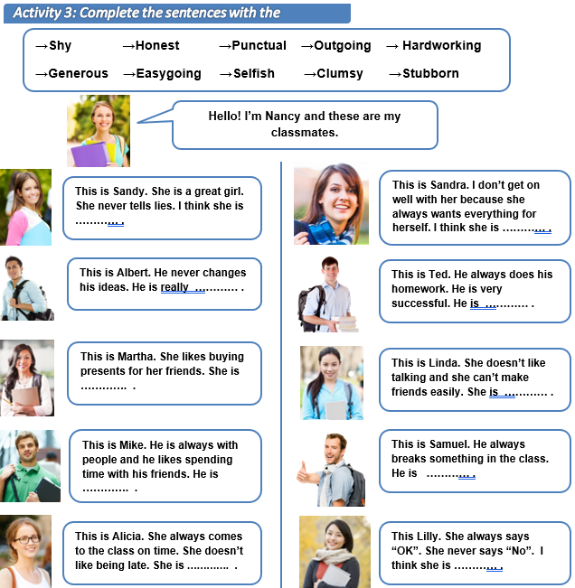
Personality adjectives

- Write the opposites (nasprotja):

- confident - shy, cautious, timid
- lazy - hardworking
- polite - impolite, rude, bad mannered
- cruel - nice, friendly
- tidy - untidy, messy, disorganized
- silly- clever, smart, wise, intelligent
- quiet – noisy, loud
- nervous - calm, relaxed, easy going
- honest - dishonest
- selfish - generous

- Answer the questions (lahko prepišeš rešene primere).

- What are you like?
I’m friendly, hardworking, but sometimes also noisy and messy.

- What do you like doing in your free time?
I like spenfing time with my friends.

- What are you good at?
I am good at sports.

- What are you bad at?
I am bad at maths.

- What are you frightened of?
I am frigtened of mean people.

- What can you do better this year?
I can work harder at school.

- What’s your favourite class at school? Why?
My favourite class is sports, because there is no homework.

- What type of music are you into? Why?
I am into rock musice, because there are many great rock bands.

- Which famous person do you like? Why?
I like Michelle and Barack Obama, because they are very intelligent and down-to-earth.

- What do you like and dislike about school?
I like it when we learn interesting things and I like that I see all my friends there. I dislike some useless things we have to learn.

- What are you really looking forward to this summer?
I am looking forward to going on holidays.

- What do you hope to do next year?
I hope to get a summer job and visit some new countries.

