TJA 7.b – TOR 14. 4.

- Najprej preglej in po potrebi popravi tabelo s stopnjevanjem kratkih pridevnikov, ki si jo v zvezek napisal včeraj.

OSNOVNIK | PRIMERNIK (…er) | PRESEŽNIK (the …est) | PROTIPOMENKA
short | shorter | the shortest | LONG
hot | hotter | the hottest | COLD
dry | drier | the driest | WET
simple | simpler | the simplest | COMPLICATED
easy | easier | the easiest | DIFFICULT
wet | wetter | the wettest | DRY
good | better | the best | BAD
fast | faster | the fastest | SLOW
cheap | cheaper | the cheapest | EXPENSIVE
bad | worse | the worst | GOOD
nice | nicer | the nicest | RUDE
slow | slower | the slowest | FAST, QUICK
tall | taller | the tallest | SHORT
new | newer | the newest | OLD
young | younger | the youngest | OLD

- Danes si bolj natančno pogledaš srednji stolpec (PRIMERNIK).
Za ogrevanje si poglej tale video: https://www.youtube.com/watch?v=lDmjvFOdxvY

- V zvezek napiši naslov, datum in razlago na tej in naslednji strani.

The Comparative = Primernik 15. 4.

Monica is 12 years old. Kelly is 15 years old.
- Monica is younger than Kelly. Kelly is older than Monica.

Mr Hope is always nice. Mrs Hope is sometimes nice.
- Mr Hope is nicer than Mrs Hope.

Learning from home – you learn by yourself. Learning at school – the teacher explains things to you.
- Learning at school is easier than learning from home.

- dodaš …ER THAN
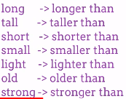

- dodaš …R THAN, ker se beseda že konča na E (potem pa spet …ER THAN)
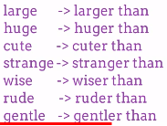

- ker je pred Y soglasnik, ga spremeniš v I (potem pa spet …ER THAN)
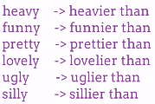

- ker je beseda zelo kratka, zadnjo črko podvojiš (potem pa spet …ER THAN)
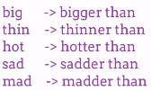

- Ustno stopnjuj pridevnike v vaji U 98/3.

slika 1: taller than - shorter than, slika 2: taller than - smaller than, slika 3: longer than - shorter than, slika 4: fuller than - emptier than…

- Naredi vaje DZ 104/7bc, 106/10, 107/12. Pomagaj si z današnjimi zapiski.

