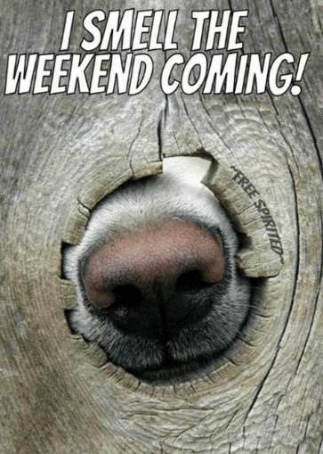
TJA 7.b – ČET 16. 4.

- Najprej preglej in po potrebi popravi vaje DZ 104/7bc, 106/10, 107/12.

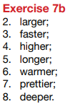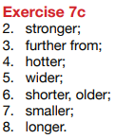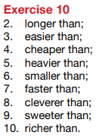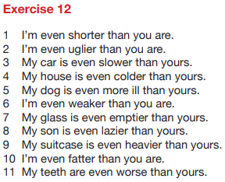

- Danes natančno pogledaš še zadnji stolpec (PRESEŽNIK).
Za ogrevanje si poglej tale video: https://www.youtube.com/watch?v=orLwiZBVoyA

- V zvezek napiši naslov, datum in razlago na tej in naslednji strani.

The Superlative = Presežnik 16. 4.

Monica is 12 years old. Kelly is 15 years old. Jane is 17 years old.
- Jane is the oldest.

Mr Hope is always nice. Ms Hope is often nice. Mrs Hope is sometimes nice.
- Mr Hope is the nicest.

- dodaš THE …EST
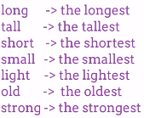
- dodaš THE …ST, ker se beseda že konča na E
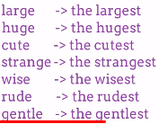
- ker je pred Y soglasnik, ga spremeniš v I
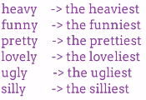
- ker je beseda zelo kratka, zadnjo črko podvojiš
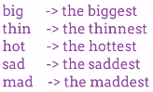

- Ustno reši vajo U 101/4. Delaj tako, kot kaže primer.
Izberi 3 primere iz te vaje in jih zapiši v zvezek.

- Reši UL (na naslednjih 2 straneh).
UL lahko prepišeš ali pa natisneš.
Rešene vaje slikaj in pošlji na mail do PON 20. 4.

SHORT ADJECTIVES – MAKING COMPARISONS

1. Dopolni drugo poved tako, da ne spremeniš pomena prve povedi.

- Tim is older than Sarah. (young)
Sarah is younger than Tim.

- Our house is larger than yours. (small)
Your house is ____________________________________________________.

- Bill is taller than David. (short)
David is ________________________________________________________.

- Jack’s marks are worse than mine. (good)
My marks _________________________________________________ Jack’s.

- Your bike is slower than mine. (fast)
My bike ________________________________________________________.

2. Dopolni povedi tako da vstaviš »the + presežnik«.

- Who’s the best (good) footballer in Europe?
- This was ______________ (cheap) watch that they had in the shop.
- The blue whale is ______________ (large) of all the animals.
- ______________ (old) university in the world is in Morocco.
- I think that was one of ______________ (bad) days of my life.

3. Pridevnike v oklepaju postavi v ustrezno obliko.

- Ben is a tall boy. He’s taller than Tony. He’s the tallest boy in his class. (tall)
- Mandy is a ______________ pupil. She’s ______________ pupil in our class. She’s much ______________ than Jane. (good)
- Is John a ______________ football player? Yes, he’s ______________ player in our team. He’s even ______________ than little Bobby. (bad)
- New York is a ______________ city. It’s ______________ city in the USA. (big)
- Storžič is a ______________ mountain, but Triglav is ______________ in Slovenia. (high)
- Is the Soča ______________ than the Sava? (long)
- Which is ______________ month in the year? (short)
- This year the weather is ______________ than last year. (bad)
- Wine is ______________ in Slovenia than in GB. (cheap)
- He thinks he’s ______________ pupil in the class. (good)
- There are ______________ shops in London than in other towns. (good)
- Bananas are ______________ than oranges. (sweet)
- This is ______________ story in the book. (short)
- Paul’s homework is ______________ of all. (bad)

