FINAL REVISION on the Past Simple Tense

Name: ____________________ Class: 7. _____ Date: March, 2020

1. Dopolni tabelo

POSITIVE (trdilna oblika) | NEGATIVE (nikalna oblika) | QUESTION (vprašalnica)
 | She wasn't ill yesterday.
 |  | Did you have a toothache?
They flew to the USA last month.

 | He didn't study very hard.

2. Dopolni sestavek z was ali were.

Rush hour
The day before yesterday I was on a bus going to Piccadily Circus. It __________ the rush hour and the bus ___________ very crowded. There __________ a fat woman with her three fat children. There __________ a thin man with his two thin children. There _________ a man with a big dog and a woman with a little dog. There __________ people with bags and people with umbrellas. There __________ people upstairs and people downstairs. There __________ no seat for me. I hate rush hours.

3. Poveži vprašanja s pravilnimi odgovori.

1 | What was your favourite toy? |  | No, they didn't.
2 | Was your hair long when you were a baby? |  | It was rainy.
3 | What time were you born? |  | Miss Green.
4 | Did they have fridges sixty years ago? |  | No, it was short.
5 | Where were you yesterday? |  | Green.
6 | What was the weather like? |  | At home.
7 | Who was your class teacher in the first form? | 1 | A teddy bear.
8 | What colour were your eyes? |  | At 8 pm.

4. Obkroži pravilni odgovor.

- What colour _________ your eyes when you were a baby?

A was | B blue | C were | D are

- Roald Amundsen travelled to the South Pole. He __________ travel to the North Pole.

A didn't | B isn't | C wasn't | D weren't

- __________ those days they washed their clothes by hand.

A by | B at | C on | D in

- Leon Štukelj lived __________ 1898 to 1999.

A and | B to | C between | D in

- __________ knighted Charlie Chaplin? – Queen Elizabeth.

A How | B Who | C When | D Why

- __________ the age of 22, she moved to England.

A by | B for | C to | D at

5. Povedi postavi v navadni sedanjik ali navadni preteklik. Pazi na časovne izraze.

THE PRESENT SIMPLE TENSE | THE PAST SIMPLE TENSE
The weather is very nice this week.

 | They travelled to the USA.
 | She had a cat.
My father sells cars.

 | He felt great yesterday.

6. Dopolni povedi. Prva črka besede je že zapisana.

Queen Vicoria ruled in Britain in the 19th c__________________.
Mozart was an Austrian composer and Prešeren was a Slovene p___________________.
Walter believes that he is b_________ off than his grandfather.
Sixty years ago people had a p________________ instead of a fridge.
Charlie´s films were first s____________ and later s____________.
7. Izberi ustrezno besedo iz okvirčka. Dve besedi sta odveč.

at easy company in tramp on black producer received career difficult believed

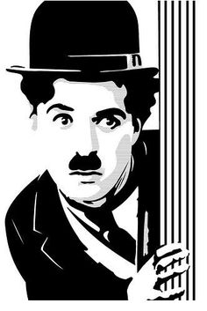
Sir Charlie Chaplin, a famous English comedian, director and _________ was born in 1889 in London. His childhood wasn’t _________ because his parents weren’t well off. The situation became even worse when his father died. Charlie had to live _____ a children’s home. Life was hard there, but he always _________in himself.
He started his film ____________ in America. By earning a lot of money he could form his own film-making _______________. He played the role of a ________ in more than seventy films. He had black hair, a moustache and was dressed in _________. He usually carried a walking stick. He _____________ an Oscar, an American film award in 1972. Chaplin died _____Christmas day, in December 1977.

8. Form questions.
(Tvori vprašanja.)

__________________________________________________________________________
No, they didn't. Only rich people had televisions in those days.

__________________________________________________________________________
The Panama canal opened in 1930.

__________________________________________________________________________
Madonna was born on 16th August, 1958.

__________________________________________________________________________
No, she didn't. She was at home because she was ill.

__________________________________________________________________________
My brother broke a vase.

9. Natančno preberi besedilo v prilogi in reši spodnje naloge.

A) Ali trditve držijo ali ne? Označi pravilen odgovor. Napačne trditve popravi.

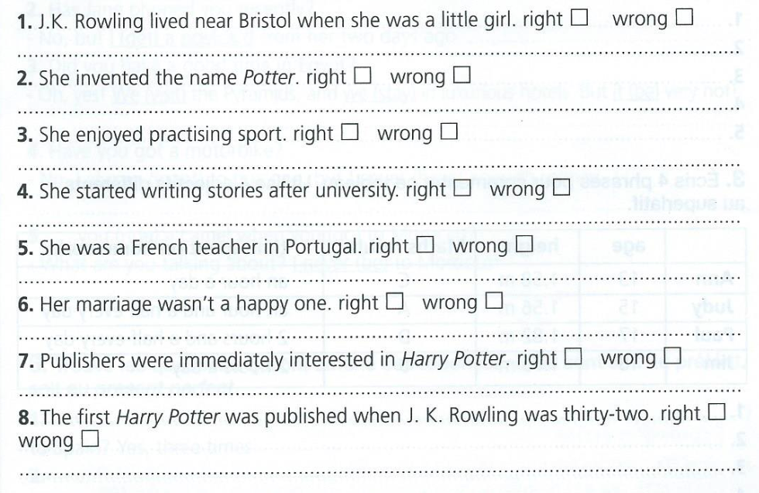

B) V besedilu izpiši 5 nepravilnih glagolov in dopolni tabelo. Glej primer, ki je že rešen.

NEDOLOČNIK | PRETEKLIK | PREVOD
BE | WAS | biti

C) Tri glagole iz razpredelnici uporabi v svojih povedih. Povedi naj bodo v pretekliku.

_______________________________________________________________________.

_______________________________________________________________________.

_______________________________________________________________________.

JOANNE KATHLEEN ROWLING

