TJA 7.b – Preverjanje znanja. Pri reševanju si lahko pomagaš z zapiski v zvezku, U in DZ. Rešuj po delih: ČET 28. 5. naloge 1-5, PON 1. 6. naloge 6-10.

REVISION on the Past Simple, large numbers, adjectives, countries Class 7

May 2020

1. Preberi sestavek o Novi Zelandiji (v prilogi – zadnja stran) ter reši nalogi A in B.

A) Ugotovi, ali so spodnje trditve pravilne T – true ali napačne F – false. Glej primer, ki je že rešen. 6/ ____

 | T | F
New Zealand is a big country. |  | X
New Zealand is as large as California.
There is a variety of countryside.
Queenstown is the capital of New Zealand.
Wellington is the largest city in New Zealand.
A part of Mount Cook is always covered in snow.
The inhabitants of New Zealand are called Kiwis.

B) Na kratko odgovori na vprašanja.
5/ ____
What’s the population of New Zealand? 4.5 million
What are the official languages? _______________________________________________
What’s the name of their money? ______________________________________________
Why is New Zealand sometimes called a natural theme park? _________________________________________________________________________
Name three adventure sports you can do there.
____________________, ____________________, _______________________
Why is Aukland called the City of Sails? __________________________________________

2. S pomočjo podatkov v tabeli tvori smiselne povedi. Številke zapiši z besedo. Glej primer, ki je že rešen. 6/ _____

Jim | Lake Bohinj | the Drava | Mt Cook | Columbus - birth
1,54 cm | 45 m | 707 km | 3,754 m | 1451

a) Jim is one hundred and fifty-four cm tall.

b) ________________________________________________________________________

c)________________________________________________________________________

d) ________________________________________________________________________

e) ________________________________________________________________________

3. Dopolni razpredelnico z manjkajočo obliko pridevnika. 10/ _____

POSITIVE  (osnovnik) | COMPARATIVE  (primernik) | SUPERLATIVE  (presežnik) | OPPOSITE  (protipomenka)
far

 | wetter
wide

 |  |  | brave
difficult

4. Dopolni povedi z ustrezno stopnjo pridevnika: osnovnik, primernik ali presežnik. Ne pozabi uporabiti than/the/as…as, kjer je to potrebno. 10/ _____

- The trip was ____________________________ the last one. (interesting)
- He’s ____________________________ girl at our school. (beautiful)
- Your room is __________________________ my room. (dirty)
- I’m ____________________________ member of our family. (young)
- My sister isn’t _________________________ me. She’s shorter. (tall)
- It’s very ______________________ today. (windy)
- Helen is _______________________ girl in our class. (thin)
- I don’t think we’ll have much sun today. The weather is getting ____________. (bad)
- A cheetah is __________________ a lion. (fast)
- Which is _______________________: lead or gold? (heavy)

5. Povedi napiši drugače. Ne uporabi več kot tri besede. Poved naj ima enak pomen kot napisan stavek.
5/ _____
0. English is easier than German. German isn’t as easy as English.

  - David isn’t as brave as Max. Max is _______________________________ David.

  - Josh is better at Maths than Nick. Nick isn’t _____________________ at Maths ____________ Joe.

  - Everything on the menu is cheaper than the steak. The steak is _________________ thing on the menu.

  - Rebecca is 1.69 m and Sophie is 1.80 m. Sophie is ________________________ Rebecca.

5. I don’t know anyone who is smarter than you. You are __________________person I know!

6. Vpiši manjkajoče besede (države, narodnosti, jeziki). Pazi na zapis besed. 6/ _____

- Tobias is from the Netherlands. He is D______________________.
- Astrid is from F_______________________. She is Finnish.
- Los Angeles is very S ________________________ in character.
- The first Olympic Games were in G____________________.
- Pippi Longstocking is from S_________________________.
- I love the sweet smell of this F_______________ perfume. I bought it in Paris.

7. Vpiši manjkajoče besede. 8/ _____

- Australia covers an A___________________ of 7,686,850 sq km and has a P_______________________ of around 25 million people.
- The C____________________ of the USA is Washington, DC.
- She is as beautiful as a P________________ and he is as busy as a B__________.
- Her room is messy, but my room is always T_______________.
- Black Africans worked in America as S____________________.
- How F_____________ is it from Ljubljana to Kranj? – About 20 km, I think.

8. Glagole v oklepaju postavi v navadni sedanjik (The Past Simple Tense). 10/ _____

- I _______________________ (move) here nine years ago.
- I _______________________ (start) skating four years ago.
- He _______________________ (meet) her in June.
- You _______________________ (not buy) the present yesterday.
- Mr Jones _______________________ (live) here six months ago.
- I _______________________ (leave) that school four years ago.
- He _______________________ (begin) working in Ireland in 1999.
- Last year he _______________________ (teach) children how to play the guitar.
- _______________________ (they / see) Riverdance when they were in Ireland?
- He _______________________ (change) his job in February and is now a policeman.

9. Zapiši vprašanja za podčrtane dele povedi. 5/ _____

- ____________________________________ ? Yes, it was. The hotel was very good.

- ____________________________________ ? Pablo Picasso lived in Spain.

- ____________________________________ ? Monica tidied up her bedroom because her mum insisted.

- ____________________________________ ? He bought a new bike last week

- ____________________________________ ? They were good at taking photographs.

10. PISNI SESTAVEK.

My classmates & me

Piši o sebi in sošolcih:

- Napiši/Primerjaj, kdo je naj (višji, starejši, mlajši ...) v razredu,
- Napiši/Primerjaj, kdo ima naj (daljše lase, težjo torbo ...) v razredu,
- Primerjaj sebe s posameznimi sošolci (5 primerjav).

Uporabi vsaj 10 različnih pridevnikov (v osnovniku primerniku in/ali presežniku).

_________________________________________________________________________________________________________________________________________________________________________________________________________________________________
_________________________________________________________________________________________________________________________________________________________________________________________________________________________________
_________________________________________________________________________________________________________________________________________________________________________________________________________________________________
_________________________________________________________________________________________________________________________________________________________________________________________________________________________________
_________________________________________________________________________________________________________________________________________________________________________________________________________________________________
_________________________________________________________________________________________________________________________________________________________________________________________________________________________________

Vsebina: 3/ _____ Besedišče: 3/ _____ Slovnica: 3/ _____

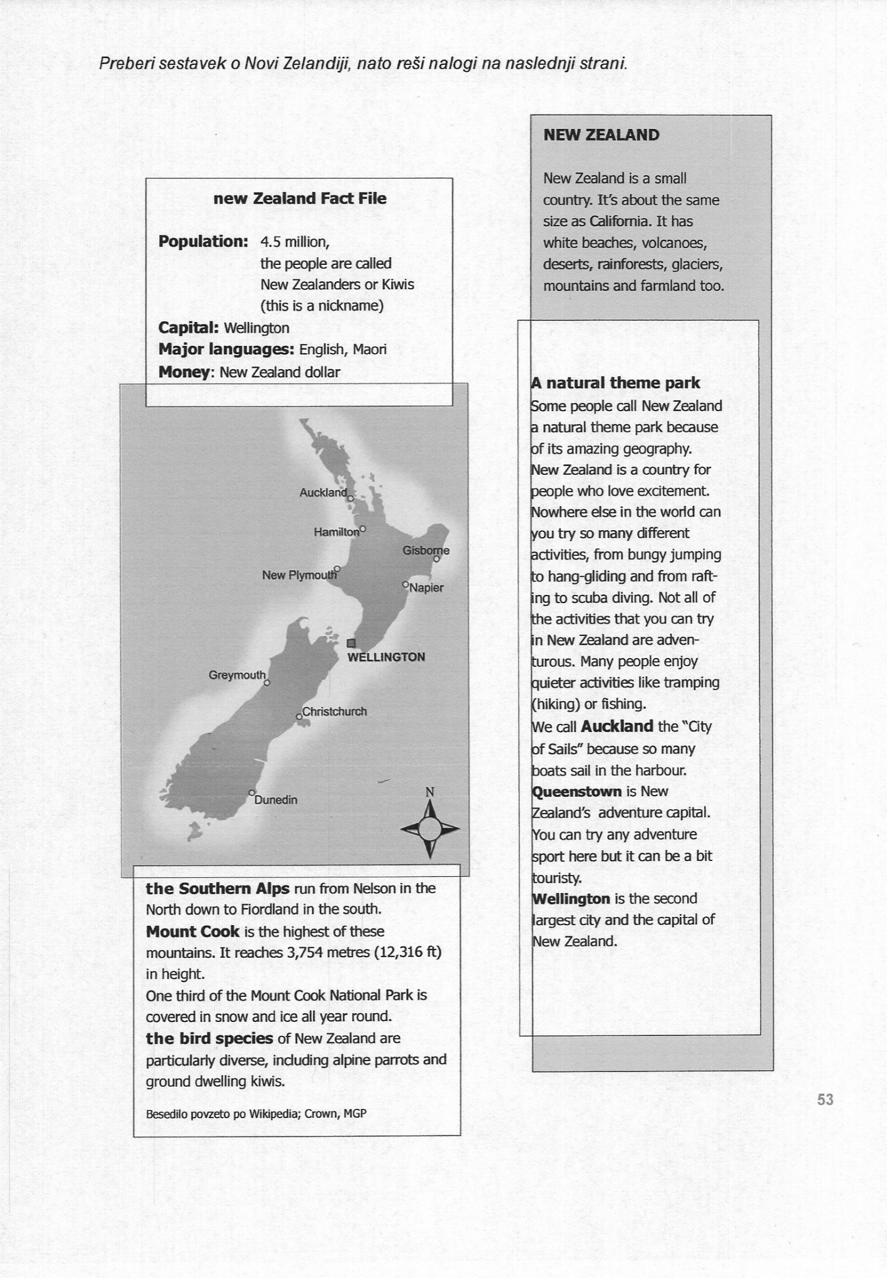
PRILOGA: BRALNO RAZUMEVANJE

