TJA 7.b – ČET 7. 5.

Še danes se ukvarjaš z besedilom v U 105.

- V zvezku preveri včerajšnje prevode.

the White House – Bela hiša
district – območje
film capital of the world – filmska prestolnica sveta
border – meja
sign – znak, napis
the official language – uradni jezik
Independence Day – Dan neodvisnosti
celebrate – praznovati
to become independent – postati neodvisen, samostojen
variety of nationalities – raznolikost narodnosti
immigrant – imigrant, priseljenec
the first inhabitants – prvi prebivalci
Dutch – Nizozemci
slave – suženj

- Še enkrat poslušaj posnetek in zraven beri besedilo The USA v učbeniku: https://touchstone.si/audio/ts7/105_The_United_States_of_America.mp3

- Besedilo The USA preberi naglas. Potrudi se za čim bolj tekočo in mehko izgovorjavo

- V zvezek prepiši vprašanja in napiši odgovore.

- Is the USA the largest country in the world?
- Is it poor?
- How many states are there in the USA?
- What`s the capital?
- Where does the President work and live?
- Who`s the current* president of the USA? (current* poišči prevod, če ne poznaš besede)
- Name some most important cities!
- What`s Hollywood?
- Why is it very Spanish in character?
- What`s the official language?
- What`s the most common language beside English?
- What`s the most popular sport?
- What`s the most important American holiday?
- Why is the USA so attractive and interesting?
- Who were the first inhabitants?
- Where did the immigrants come from?
- Where did the black people come from?
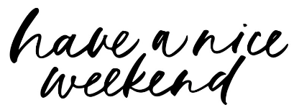
- What were the first black people in the USA?

