**ČETRTEK, 28. 5. 2020**

TJA 7. A

Najprej natančno preglej rešitve naloge. Kako ti je šlo 😊?

**UČ str. 112/6a**

* The kangaroo **is from** Australia. = The kangaroo **comes from** Australia.
* Lego bricks **are from** Denmark. = Lego bricks **come from** Denmark.
* Bullfights are from Spain/Portugal.
* The Eiffel Tower is from France.
* The kozolec is from Slovenia.
* The Beetle is from Germany.
* Red double deckers are from GB.
* Spaghetti are from Italy.
* The Olympic Games are from Greece.
* The St. Bernard dog is from Swtizerland.
* The sauna is from Finland.
* Yodelling is from Austria. / Yodeelers are from Austria.
* The Atomium is from Belgium.
* Wind mills are from the Netherlands.
* The buffalo is from the USA.
* Guiness beer is from Ireland.
* Pippi Longstocking is from Sweden.
* Count Dracula is from Romania.

**DZ str. 116/29 in str.117/31**

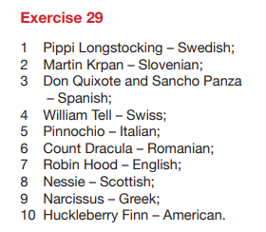 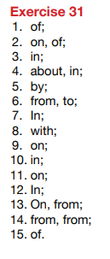



Pred vami je pisanje krajšega sestavka.

Opisali boste eno od angleško govorečih držav: Novo Zelandijo, Avstralijo, Irsko ali Veliko Britanijo. Naslov v zvezku je enak naslovu opisane države (npr. New Zealand).

Vse podatke najdete v delovnem zvezku: **DZ str. 121/2a**.

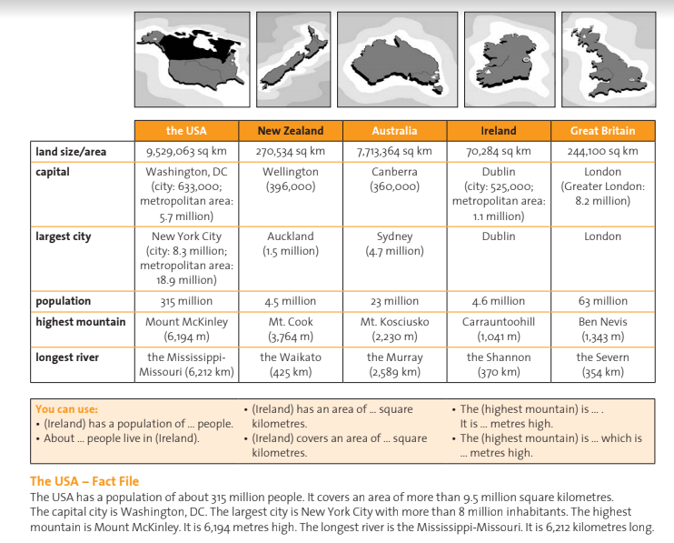

**PRIMER:**

**UPORABNE FRAZE …**

prebivalci

velikost

Želim ti veliko ustvarjalnega navdiha!

… ko opisuješ najvišjo goro/najdaljšo reko.

… ko opisuješ velikost države.

… ko opisuješ število prebivalcev.