**ČETRTEK, 23. 4. 2020**

TJA 7



VIDEOKONFERENCA - OPOMNIK

**DANES ob 10.uri**

Povezava: <https://us04web.zoom.us/j/73293965294>

Meeting ID: 732 9396 5294

Potrebuješ peresnico in potrebščine za TJA.

Rešitve nalog:

**UČ str.101/3**

BUILDINGS: Building are redder in GB.

GRASS: Grass is greener in GB.

PEOPLE: In GB people are quieter. In Canada people are louder.

MANNERS: British manners are better. Canadian manners are worse.

TRAVELLING: Travelling in GB is easier. Travelling in Canada is harder.

LAND AREA: GB is smaller. Canada is bigger.

MOUNTAINS: Mountains in GB are lower. Mountains in canada are higher.

RIVERS: Rivers in GB are shorter. Rivers in Canada are longer.

COUNTRYSIDE/LANDSCAPE: British landscape is more beautiful.

WEATHER/CLIMATE: The weather/climate in GB is warmer/better. The weather/climmate in Canada is colder/worse.

FOOD British food is worse. Canadian food is better.

BEER British beer is worse. Canadian beer is better.

COFFEE British coffee is worse. Canadian coffee is better.

**DZ str. 108/14,15**

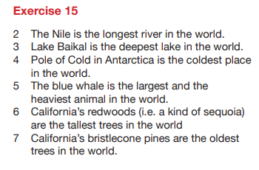 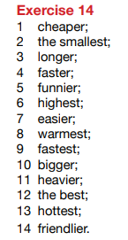

Po videokonferenci boš rešil(a) še te naloge:

**⮚ DZ** str. 109/18, 110/19a, 19b

Danes lahko že takoj preveriš rešitve naloge 😉:

