**Plan dela za 6.a: sreda, 13.05.2020**

E-mail: [mateja.arh@oskoroskabela.si](mailto:mateja.arh@oskoroskabela.si)

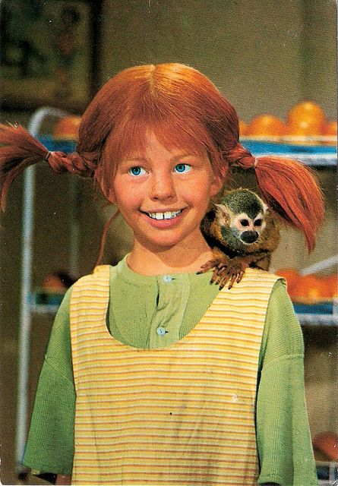 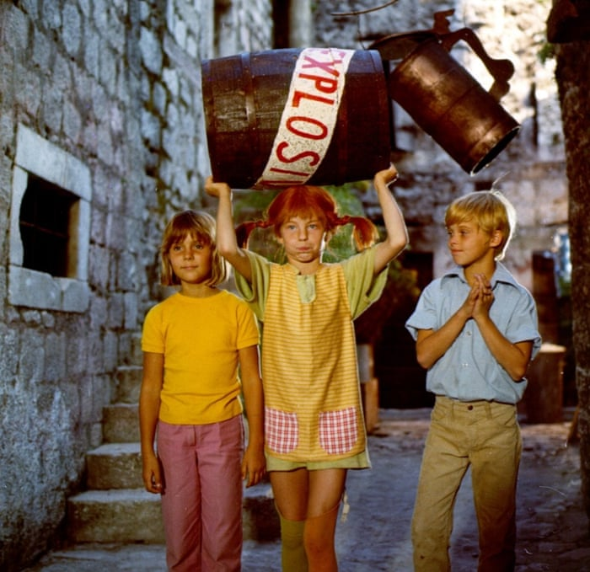

***Astrid Lindgreen: Pippi Longstocking ( Pika Nogavička)***

**1. UVODNA MOTIVACIJA**

►oglej si zgornje slike in razmisli ali si že gledal/a risanko ali film o Piki Nogavički. Poskusi se spomniti imen drugih junakov, ki nastopajo v zgodbi?

**2. DANAŠNJA SNOV: A DAY IN THE LIFE OF PIPPI LONGSTOCKING – DAN V ŽIVLJENJU PIKE NOGAVIČKE**

***● UČB str. 97, naloga 1a***

- v zvezek zapiši naslov **PIPPI LONGSTOCKING**, prepiši spodnje besedilo ter vstavi manjkajoče besede. ( Opis Pike Nogavičke) Pomagaj si z nalogo 1a.

*Pippi's hair is red as a ______________. She wears two pigtails that ___________________________________________. Her nose is very ________ and dotted with _____________. Her dress is very ___________. It's yellow and too ___________. Pippi wears blue ______________ with white dots and long _______________ - one is striped and the other is ____________. Her shoes are __________ and they are twice as ___________________________.*

- neznane besede iz naloge 1a prepiši v zvezek in najdi prevode v slovarčku.

● ***UČB str. 97, naloga 1c***

- poslušaj posnetek in zraven beri besedilo.

<http://www.e-gradiva.com/dokumenti/T6/P/U3B1.mp3>

- poveži angleške besede s slovenskimi prevodi. Pomagaj si z nalogo 1c in slovarčkom. Besede prepiši ali zalepi rešen učni list v zvezek.

|  |  |  |  |
| --- | --- | --- | --- |
| 1____ | get up | A | zajtrkovati |
| 2____ | turn on | B | poiskati |
| 3____ | have breakfast | C | obleči se |
| 4____ | have a shower | D | uživati |
| 5____ | get dressed | E | gledati televizijo |
| 6____ | look for | F | vstati |
| 7____ | go to school | G | iti domov |
| 8____ | ride a horse | H | pripovedovati zgodbe |
| 9____ | enjoy | I | prižgati |
| 10____ | have lunch | J | tuširati se |
| 11____ | go home | K | iti v šolo |
| 12____ | do the homework | L | telovaditi |
| 13____ | tell stories | M | jesti kosilo |
| 14____ | have dinner | N | iti spat |
| 15____ | watch TV | O | jahati konja |
| 16____ | go to bed | P | narediti nalogo |
| 17____ | wake up | R | peči piškote |
| 18____ | do exercises | S | večerjati |
| 19____ | turn somersaults | T | iti po nakupih |
| 20____ | bake biscuits | U | metati žogo |
| 21____ | make pancakes | V | zalivati vrt |
| 22____ | water the garden | Z | zbuditi |
| 23____ | go shopping | W | delati premete |
| 24____ | prepare dinner | Q | delati palačinke |
| 25____ | go for a walk | Y | pripraviti večerjo |
| 26____ | toss a ball | X | pripovedovati pravljico |
| 27____ | tell a fairy-tale | # | iti na sprehod |

**3. UTRJEVANJE**

● ***DZ str. 86-87, naloga 41 = reši***

V prvi izpolnjeni tabeli boš dobil/a podatke, katere postaviš v stavek v tabeli 2. Zapis stavkov je v navadnem sedanjiku. Poglej še enkrat pravila.

**4. REŠITVE**

● **UČB str. 94, naloga 1a**

3 rich; 6 swimming pool; 1 limousine; 4 nanny; 5 expensive; 2 restaurant

● **Slovarček besed**

|  |  |
| --- | --- |
| **ENGLISH** | **SLOVENE** |
| RICH | bogat |
| SWIMMING POOL | bazen |
| LIMOUSINE | limuzina |
| NANNY | varuška |
| EXPENSIVE | drag |
| RESTAURANT | restavracija |
| PRESENT | darilo |
| THAT’S A NICE SURPRISE | To je lepo presenečenje |
| MANY HAPPY RETURNS | na mnoga leta |
| A BOX OF CHOCOLATES | mombonjera |
| CAN I ASK YOU FOR A DANCE? | Ali te lahko prosim za ples? |
| A GREEN SCARF | zelen šal |
| LET’S DANCE! | Zaplešiva! |
| A PAIR OF EARINGS | par uhanov |
| A RING | prstan |
| A BRACELET | zapestnica |
| A NECKLACE | ogrlica |
| A DIARY WITH A KEY | dnevnik s ključem |
| COLOURED WRITING PAPER | barvni pisalni papir |
| A SMALL BOTTLE OF PERFUME | majhna steklenička parfuma |
| A BRUSH AND COMB SET | kompleta krtače in glavnika |
| A PACK OF CARDS | komplet kart |
| A JIGSAW | sestavljanka |
| A GAME | igra |
|  |  |

● **DZ str. 84, naloga 36**

Primer:

1 You: Happy birthday,Caroline.

2 Caroline: Thank you.

3 You: Here’s a present for you.

4 Caroline: How nice. What is it?

5 You: A CD of your favourite songs.

6 Caroline: That’s great. Thank you very much.

● **UČB str. 96, naloga FUN-TASTIC**

