Plan dela za 6.a: sreda, 20.05.2020
E-mail: mateja.arh@oskoroskabela.si
1. UVODNA MOTIVACIJA
► za začetek ponovite že znano besedišče, ki se nanaša na dnevno rutino.
https://www.youtube.com/watch?v=M4FMEmlOqTM

2. DANAŠNJA SNOV: A TYPICAL DAY – OBIČAJEN/NAVADEN DAN
► UČB str. 100, naloga 3b
- v zvezek zapiši naslov A TYPICAL DAY, preriši tabelo in vanjo vnesi podatke za sebe. Pomagaj si s primeri v učbeniku. Zapiši kaj vse počneš zjutraj, popoldne in zvečer.
In the morning I | In the afternoon I | In the evening I
get up | get home | have dinner

3. UTRJEVANJE
► DZ str. 88, naloga 43 = reši
► DZ str. 89, naloga 44abc = reši

4. REŠITVE
► DZ str. 85, naloge 37,38,39
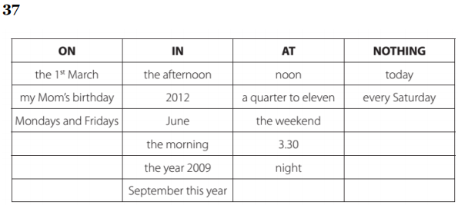
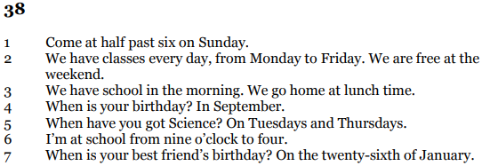
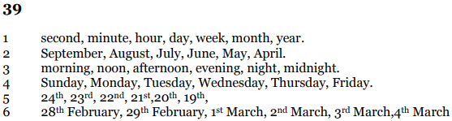
►UČB str. 96, naloga 3 ( v zvezek)
Anna’s birthday is ON the sixteenth OF December. She has a party AT four o’clock. She is at school FROM 9 o’clock TO 3 o’clock every day, except ON Saturdays and Sundays. Her school is very old. It will be 200 years old IN the year 2012.
► Rešitve izziva: skbno preglej in si popravi napake!!!
1. Naloga:
Prepiši vprašanja in jih dopolni z ‘’Do’’ ali ‘’Does’’. Odgovori na vprašanja na daljši, vljudnejši način. (Yes ali No ni zadosti). Pomagaj si s primeri v UČB na str. 99, naloga 2c.

- DOES Tommy and Annika's father turn on the radio in the morning? No, he doesn’t.
- DO Tommy and Annika wake up Pippi? No, they don’t.
- DOES Pippi still sleep at 7 o'clock? Yes, she does.
- DOES Pippi go to school? No, she doesn’t.
- DO Tommy and Annika like P.E.? Yes, they do.
- DOES Pippi work in the garden? Yes, she does.
- DO Pippi, Tommy and Annika have fun? Yes, they do.
- DO the children ride a bike? No, they don’t.
- DOES Pippi go to bed at midnight? Yes, she does.

2. Naloga:

Prepiši vprašanja in vstavi ustrezne vprašalnice ‘’when/what time, what, who, why, where’’. Na vprašanja odgovori na dolgo. ( Glej primere v UČB na str. 99, naloga 2a, 2e…) Podatke najdeš v besedilu.

- WHAT does Pippi do at 8 a.m.? She does her morning exercises.
- WHEN/WHAT TIME do Tommy and Annika go to school? They go to school at 8.20
- WHERE does Pippi go in the afternoon? She goes shopping on her horse.
- WHY do the children have fun? (vprašaj po razlogu) Because they eat biscuits and Pippi tells interesting stories.
- WHO prepares dinner for Mr Nelson and the horse? Pippi prepares dinner for Mr Nelson and her horse.
- WHY are Tommy and Annika at home at 6:30? Because they have dinner.
- WHERE is Pippi at 8 p.m.? She is in the kitchen and counts her gold pieces.
- WHERE do Tommy and Annika go at 8 o’clock? They go to their room and talk about Pippi.
- WHO sleeps at 10 p.m.? Tommy and Annika sleep at 10 p.m.

