**Navodilo za delo v TOR 4. 5.**

Če želiš, lahko za ogrevanje poslušaš in prebereš besedilo o 6.b razredu iz Velike Britaniije 😊 Najdeš ga v U 87, lahko pa rešiš tudi uganke v U 88/6b.

Zvočni posnetek: <http://www.e-gradiva.com/dokumenti/T6/P/U3CHILDREN.mp3>

1. **Preglej** vaje **DZ 79+80/23-25ab**.

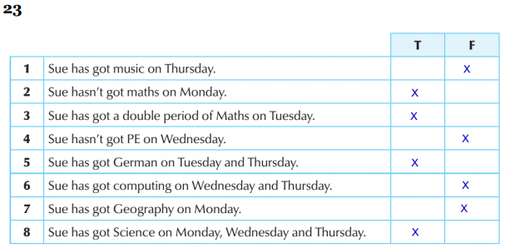

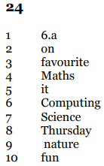 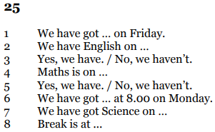

1. **Preberi in poslušaj** besedilo **U 89/1**.

Posnetek: <http://www.e-gradiva.com/dokumenti/T6/P/U3A5.mp3>

1. V zvezek **zapiši** spodnji naslov, datum in snov.

**Dates = Datumi** 5. 5.

What are your favourite dates? – My birthday and the last day of school.

What’s the date today? – It’s 5th May.

What day is the 13th of May? – It’s Wednesday.

When’s your birthday? – In October. / On 3rd October.

When’s your nameday? – It’s on 27th December and on 14th February.

When’s New Year’s Day? – It’s on 1st January.

zeleno obarvani 🡪 vrstilni števniki = ordinal numbers

(to snov imaš v zvezku in na učnem listu 24., 25. in 27. septembra)

Dodatna pomoč: U 90/6 – ta teden jo kar uporabljaj 😊

1. **Poglej** posnetek: <https://www.youtube.com/watch?v=Z6XQCKZqIYI>
2. **Ustno** preberi vrstilne števnike **U 89/2**. V vsaki vrstici (A, B, C) si jih izberi vsaj pet.
3. V zvezek prepiši **tabelo** in jo **dopolni**. Glej primer.

|  |  |
| --- | --- |
| **Zapis** | **Izgovorjava** |
| *30th September* | *the thirtieth of September* |
|  | the fifteenth of March |
| 22nd December |  |
|  | the tenth of July |
| 18th May |  |
|  | the twentieth of February |
| 1st January |  |
|  | the thirteenth of April |
| 3rd October |  |
|  | the twelfth of November |

1. Reši vaje **DZ 81/27-29**.