**Navodilo za delo:**

S pomočjo rešitev (spodaj) preglej preverjanje znanja, ki si ga dobil v PET 20. 3.

Lahko prevzameš vlogo učitelja in si preverjanje točkuješ.

**Točko** dobiš samo, če je **rešitev** ali poved **popolnoma pravilna**.

Ob robu naloge imaš napisane koliko točk je možnih (____/ 6). Če si naredil samo eno napako, si pišeš, da si dobil 5/6 točk.

Na koncu točke seštej. Vseh možnih točk je 103.

Odstotke si izračunaš tako, da svoje dosežene točke deliš z vsemi možnimi – npr. 52 deljeno s 103 = 0,5048, kar je 51 % (dobiš tako, da daš decimalno vejico za 2 mesti v desno).

**Kriterij: 50-63%: zd (2), 64-77%: db (3), 78-89%: pd (4), 90-100%: odl (5)**

DN: **še enkrat preberi snov** v zvezku, U in DZ, ki se nanašajo na naloge, **pri katerih si dosegel manj kot pol možnih točk**.

**Rešitve - PRE-TEST 2 24. 3.**

1. **Slušno razumevanje. ___ / 6 točk.**

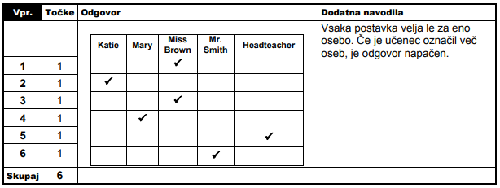

**2. Dopolni tabelo z manjkajočo obliko: trdilna, nikalna, vprašalna. ___ / 8 točk.**

|  |  |  |
| --- | --- | --- |
| **TRDILNA OBLIKA ( + )** | **NIKALNA OBLIKA ( - )** | **VPRAŠALNA OBLIKA ( ? )** |
| ***We play football.*** | We don’t play football. | ***Do we play football?*** |
| ***You are happy.*** | ***You aren't happy.*** | Are you happy? |
| She’s got a cat. | ***She hasn't got a cat.*** | ***Has she got a cat?*** |
| He collects stamps. | ***He doesn't collect stamps.*** | ***Does he collect stamps?*** |

1. **Besedilo dopolni z AM/IS/ARE ali HAVE GOT/HAS GOT. ___ / 8 točk.**

My favourite well-known person ***is*** Adele. She ***is*** a singer. She ***is*** British. She ***has got*** long brown hair and brown eyes. She ***is*** tall and thin. She ***has got*** a friendly face. She ***is*** very famous. She ***has got*** lots of beautiful dresses.

1. **Glej slike in vstavi ustrezne kazalne zaimke ( this, that, these, those) v ednini ali množini.** **___ / 9 točk.**

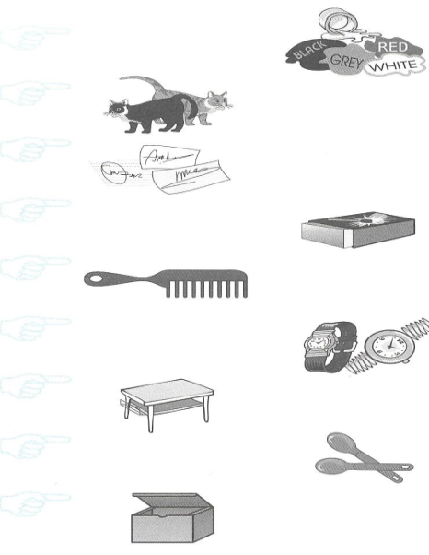

1. 1. ***These*** are colours.

2. ***Those*** are cats.

1. 3. ***Those*** are autographs.
2. 4. ***This*** is a matchbox.
3. 5. ***That*** is a comb.
4. 6. ***These*** are watches.
5. 7. ***That*** is a table.
6. 8. ***These*** are spoons.
7. 9. ***That*** is a box.

**5.** **Samostalnike postavi v množino. ___ / 8 točk.**

|  |  |  |  |
| --- | --- | --- | --- |
| a poster | ***posters*** | a witch | ***witches*** |
| a torch | ***torches*** | a box | ***boxes*** |
| a baby | ***babies*** | a sheep | ***sheep*** |
| a stamp | ***stamps*** | a child | ***children*** |

1. **Glej sliko in dopolni poved z ustreznim predlogom ( on, in, under, behind, between, in front of, next to, near). ___ / 5 točk.**

1. A table is ***in front of / near*** the sofa.

2. A vase is ***on*** the table.

3. A desk is ***behind / near*** an armchair.

4. A clock is ***between*** the pictures.

5. A dog is ***under*** the chair.

1. **A.) Poglej sliko in zapiši prostore, katere imaš na desni oštevilčene z ustrezno številko. ___ Pred prostorom stoji »a/an« ali »the«. ___/ 6 točk.**

1. an attic

10. a living room

8. a dining room

11. a garage

2. a balcony

6. a bedroom

**B.) Zapiši 4 povedi. Uporabi strukturo '' There is / are''. V povedih pravilno uporabi člene a/an ter količinska izraza ''some/any''. V vsaki povedi uporabi drugo strukturo ( a/an/some/any)!!! Glej sliko pri nalogi 6A ter primer spodaj. Pri tej nalogi je možnih veliko odgovorov, težko uganem, kakšne imaš ti, zato navajam nekaj primerov. ___/ 4 točke.**

*Primer: There are some chairs in the kitchen.*

*1.* **There is a desk in the children's room.**

*2.* ***There is an attic upstairs.***

*3.* **There are some chairs in the dining room.**

*4.* ***There aren't any people downstairs.***

**8. Glagole v oklepajih postavi v navadni sedanjik ( The Present Simple Tense). ___/ 6 točk.**

1. My mum ***does*** (do) the washing up every Saturday morning.

2. Teachers at our school ***don’t give*** (not give) us a lot of homework.

3. ***Does*** he ***play*** (play) football every day?

4. His feet ***smell*** (smell). He should wash them every day.

5. Kate never ***studies*** (study) in her room, because she ***doesn’t have*** (not have) a desk there.

1. **Popravi napake. Prečrtaj napako in na črto napiši pravilno rešitev. ___/ 8 točk.**
2. What ~~has~~ you got? ***What have you got?***
3. Jenny are twenty – three. ***Jenny is twenty-three.***
4. She'~~ve~~ got a baby. ***She's got a baby.***
5. Pete and Sue ~~got~~ blue eyes. ***Pete and Sue have got blue eyes.***
6. We ~~hasn't~~ got any children. ***We haven't got any children.***
7. My dog ~~have~~ got a tail. ~~She like~~ eating bones. ***My dog has got a tail. It likes eating bones.***
8. Susan ~~crys~~ quite often. ***Susan cries quite often.***
9. Jane doesn't ~~do always~~ her homework. ***Jane doesn't always do her homework.***

10**. Smiselno dopolni stavke. ___/ 10 točk.**

►a **r*ug*** is the same as the carpet but smaller.

► we put the clothes in the **w*ardrobe***

► books are on the **b*ookshelf***

► a bird lives in a **b*irdcage***

► In English we say '' Ne odpiraj vrat!'': D***on’t open the door***!

► '' Tidy your room, please'' is in Slovene: ***Pospravi sobo, prosim.*** (prevedi v SLO)

► Write the number 345 in words: ***three hundred forty-five***

► If somebody doesn't like something, we say he/she ***hates*** it.

► There are **c*urtains*** on the window.

► I **c*ollect*** stamps. I have a big collection of them.

**11. Bralno razumevanje**.

**A) Preberi besedilo in dopolni povedi o Kylie. ___/ 5 točk.**

1 Kylie ***lives*** in a block of flats.

2 She ***speaks*** two languages, English and Spanish.

3 She sometimes ***collects*** stickers of pop stars.

4 She ***is*** fifteen years old.

5 She ***has got*** a guinea pig.

**B) Dopolni povedi z ustrezno vprašalnico ( who, what, which, how old, how many,…) ali pomožnimi glagoli ( do, does, have/has, am, is are) ter zapiši ustrezen odgovor. ___/ 10 točk.**

1 ***Does*** Kylie live in Canada? ***No, she doesn’t.***

2 ***Does*** she collect marbles? ***No, she doesn’t.***

3 ***How many*** languages does she speak? ***Two.***

4 ***How old*** is she? ***Fifteen.***

5 ***Has*** she got a pet? ***Yes, she has.***

1. **Pisno sporočanje. Napiši vsaj 10 povedi. Prijatelju napiši pismo v in v njem:**

- opiši park na sliki

- opiši, kaj ljudje tam običajno počnejo

- zapiši pravila, ki veljajo v parku na sliki.

**___/ 10 točk. Tukaj je možnih veliko rešitev. Za vajo lahko prepišeš spodnji primer.**



Dear Jackie,

This is my park. There are some trees and there is a playground. There are many children. The children play in the park. People also walk a dog or run there. You can play basketball in the park. In this park you mustn't ride a bike, walk on the grass and pick flowers. You must throw the waste in the garbage can.

I hope we can go to the park when you visit me.

Love,

Kate