PREVERJANJE – REŠITVE
Rešitve so napisane po spominu – izvorna datoteka in natisnjeno preverjanje so ostali v šoli, tako da če je kaj »čudno«, lahko povprašaš na tina.rajhman@oskoroskabela.si.
1. NALOGA
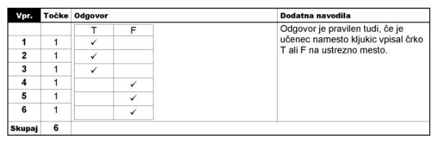

2. NALOGA
GAME MEAT
BEER/VODKA/SPIRITS (katerakoli alkoholna pijača, ki mora biti pravilno zapisana!)
SOFT/NON-ALCOHOLIC
I WANT/I'D LIKE
MEAT
YOGHURT/CREAM/CREAM CHEESE/SOUR CREAM (katerikoli mlečni izdelek, ki mora biti pravilno zapisan!)
DAIRY
CUTTING BOARD/CHOPPING BOARD
CRUNCHY
TASTELESS
ADD
MANY

3. NALOGA
8-E, 1-F, 5-B, 3-A, 9-D, 4-H, 7-G, 2-J, 10-I, 6-C

4. NALOGA

BREAKFAST: wholemeal bread, butter, honey, apple, cocoa
LUNCH: beef soup with noodles, mashed potatoes, spinach, frankfurters/Vienna sausages, apple strudel
DINNER: milk rice (pudding), raspberries

5. NALOGA
most, another, invite, together, after

6. NALOGA
- have dated/have been dating, came, drove, were using, arrived
- am going to fly/am flying, are not going (to go)
- spends, has already travelled, spent, paid, left
- is working, is putting

7. NALOGA

A)
- is, will go
- won't tell, promises
- eats, will be
- stops, will take
- won't be, melts

B) Spodnje povedi združi z IF ali WHEN.

When she grows up, she will be more self-confident.

If you don't hurry up, you'll be late for school.

If she studies harder, you'll pass the exam.

8. Preberi besedilo v prilogi 1 in reši nalogi.

A) NA KRATKO odgovori na vprašanja.

- almond
- honey
- dark chocolate
- salmon, goji berries
- broccoli
B) So spodnje trditve pravilne (TRUE), napačne (FALSE) ali podatka ni v besedilu (NOT GIVEN)?
T
NG
F
T
T
NG
F

