**TOREK, 26. 5. 2020**

TJA 7. A

DZ str. 114/25 in 26, str. 115/27

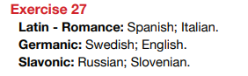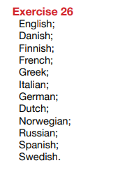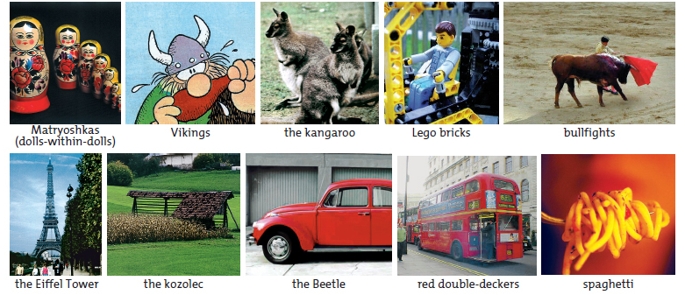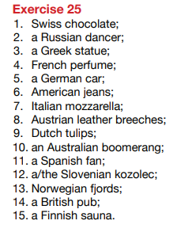

**BESEDIŠČE:**

Lego bricks = lego kocke

bullfights = bikoborbe

the Beetle = hrošč (avto)

double-deckers = dvonadstropni avtobus

the St. Bernard dog = bernardinec

yodelling = jodlanje

yodellers = jodlarji

the Atomium

wind mills = milini na veter

the buffalo = bizon, bivol

Pippi Longstocking = Pika Nogavička

Count Dracula = Grof Drakula

WHAT IS TYPICAL OF …?

**UČ str. 112/6a**

UČ 112/6a

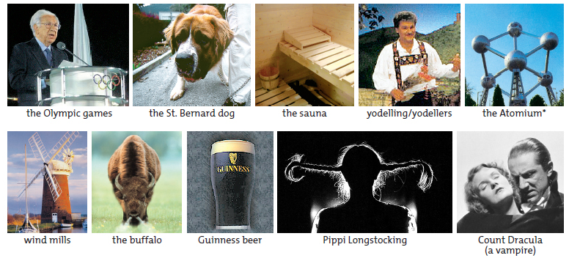

V zvezek napiši naslov What is typical of …? (= Kaj je značilno za …?).

Oglej si nalogo (UČ str. 112/6a). Napiši, **iz katere države prihajajo** stvari ali osebe na slikah.

Države:

Australia, Austria, Belgium, Denmark, Finland, France, Germany, GB, Greece, Ireland, Italy, Norway, Romania, Russia, Slovenia, Spain, Sweden, Switzerland, the Netherlands, the USA

Primer:

Matryoshkas come from Russia.

Vikings come from Norway.

Ponovi:

* DZ str. 116/29
* DZ str.117/31

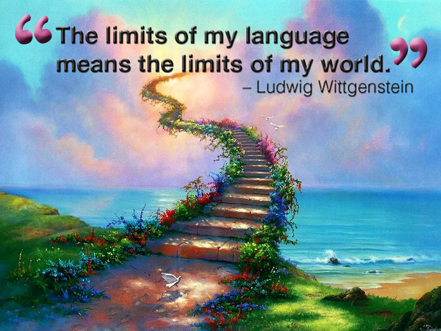

Meje mojega jezika so meje mojega sveta.

Lep dan ti želim!