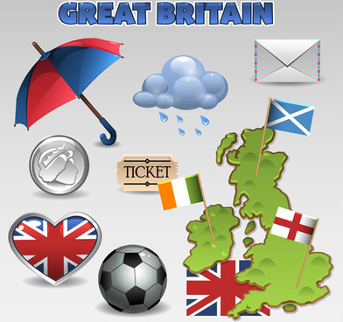**TOREK, 12. 5. 2020**

TJA 7. A

**Preglej odgovore na vprašanja:**

Which is bigger: the United Kingdom or Great Britain? The United Kingdom

The UK consists of **4** countries: England, Scotland, Wales, Northern Ireland

GB consists of **3** countries: England, Scotland, Wales

Which country is in the United Kingdom but not in Great Britain? Northern Ireland

What is the capital of *England?* London

What is the capital of *Scotland*? Edinburgh

What is the capital of *Wales*? Cardiff

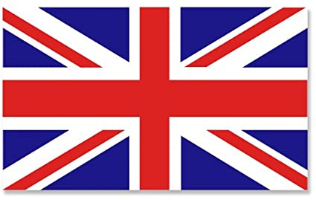What is the capital of *Northern Ireland*? Belfast

What is the biggest city in *Great Britain*? London

The United Kingdom flag is called the Union Jack. Draw it.

Danes boš prebral(a) še besedilo v delovnem zvezku in rešil(a) dve nalogi.

**DZ str. 118/2a, 2b**



Listen to the national anthem. It's called God Save the Queen.

[God Save the Queen](https://www.youtube.com/watch?v=Xm7CZvvsC64)

Queen Elizabeth II is the oldest British monarch. She was born on 21st April, 1926 and she is 94 years old.

[Queen Elizabeth II](https://www.youtube.com/watch?v=Df41G7r5tMY)