**TOREK, 21. 4. 2020**

VIDEOKONFERENCA

**ČETRTEK, 23. 4. 2020 ob 10.uri**

Povezava: <https://us04web.zoom.us/j/73293965294>

Meeting ID: 732 9396 5294

Potrebuješ peresnico in potrebščine za TJA.

TJA 7. A

1. **Prevodi** besed:

|  |
| --- |
| GLOBETROTTER – SVETOVNI POPOTNIK |
| IMPRESSION – VTIS |
| A COIN – KOVANEC  OUTGOING – DRUŽABEN |
| MANNER – VEDENJE, OBNAŠANJE, MANIRE |
| COUNTRYSIDE – PODEŽELJE |
| LANDSCAPE – POKRAJINA |
| FOREST – GOZD |
| PRAIRIE – PRERIJA |
| TUNDRA – TUNDRA  EVERGREEN – ZIMZELEN |
| INLAND – NOTRANJOST (dežele) |
| VAST FARMLANDS – PROSTRANE KMETIJSKE POVRŠINE |
| SEVERE – OSTER, ZELO MRZEL |

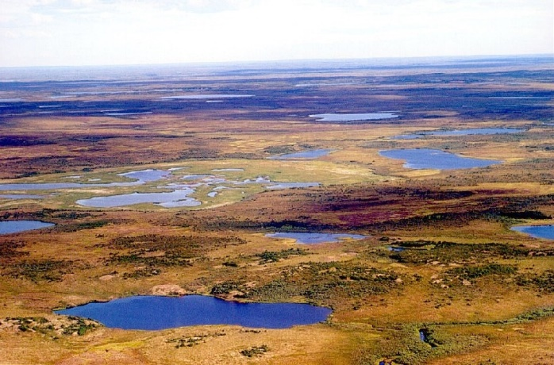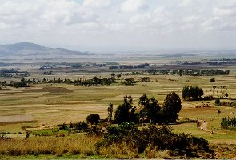

Prerija = severnoameriška stepa Tundra = pokrajina brez dreves prekrita z mahovi in lišaji

= obširen travnat svet, zanj je značilna visoka trava

2. **Odgovori** na vprašanja:

1. Where does Mrs Globetrotter come from?

From Ottawa, Canada

1. What does she like doing?

Travelling/Travels

1. How many km has she travelled so far?

2.6 million km

1. What is she talking about on a TV show?

About Britain (and Canada)

1. What do you notice first in GB?

The coins are heavier, the grass is greener,the buildings are redder.

1. What are the British like?

Quiet and not very outgoing.

1. Why is it easier to travel in Britain?

Because it is smaller.

1. How high is the highest mountain in Britain?

1,343 m.

1. What`s it called?

Ben Nevis.

1. What is British countryside like?

Beautiful.

1. What kinds of landscape has Canada got?

Forests, praries, tundra, lakes, vast farmlands …

1. What is the climate in Canada like?

Severe (very cold).

1. Is Canadian food worse than British? Why?

No. British food is worse, especially their coffee and beer.



Danes boste še sami **primerjali Kanado in Veliko Britanijo**. Naslov v zvezku je še vedno isti, naredili pa boste nalogo v učbeniku:

**UČ str.101/3**

Izberi 5 stvari in jih primerjaj. Glej primer, ki je že rešen.

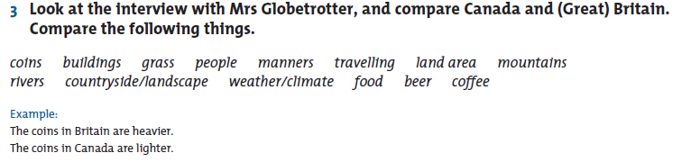

Za ponovitev stopnjevanja pridevnikov pa reši še dve nalogi v DZ:

**DZ str. 108/14,15**

