**NAVODILA: ponedeljek, 23.03.2020**

 **OSTANITE ZDRAVI!**

**Učiteljica Mateja Arh**

* Pregledaš naloge v Dz-ju s pomočjo spodnjih rešitev.

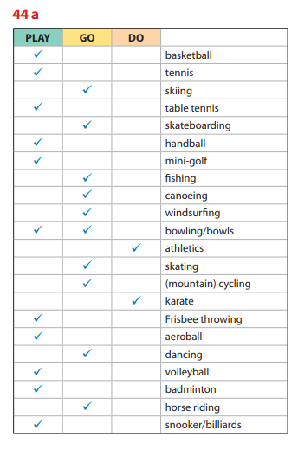

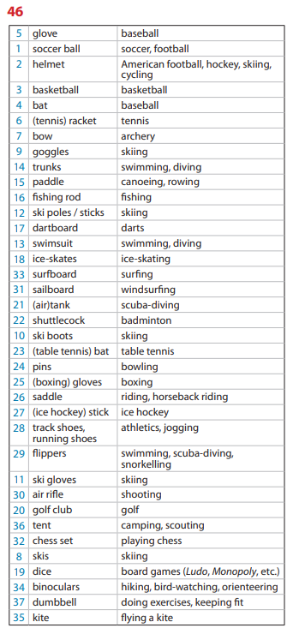

* V zvezek reši 1., 2. In 3. nalogo. Po končanem delu si preglej odgovore s pomočjo rešitev. Delaj na novem besedišču!!! Nove besede v teh 3. nalogah si zapiši v svoj slovarček besed ali v zvezek.

C:\Users\user\AppData\Local\Microsoft\Windows\Temporary Internet Files\Content.IE5\7P1NIJTM\MC900241617[1].wmf

**Choose the most suitable word underlined in each sentence.**

1. Sue came first in the 5000 metres competition / game / race.
2. Brenda goes jogging every morning to keep exercised / fit / trained.
3. Our team beat / defeated / won the match by two goals to nil.
4. The local stadium isn't large enough for so many audience / viewers / spectators.
5. I'm afraid I don't find basketball all very interested / interesting.
6. Norman won first medal / prize / reward in the cookery competition.
7. All competitors / rivals/ supporters for the relay race should make their way to the track.
8. C:\Users\user\AppData\Local\Microsoft\Windows\Temporary Internet Files\Content.IE5\7NL5AKM4\MC900212935[1].wmfThe final result was a/an draw / equal / score.

**Explain the difference between...**

1. Amateurs and professionals
2. A winner and a runner-up
3. To win and to beat
4. nil and love

C:\Users\user\AppData\Local\Microsoft\Windows\Temporary Internet Files\Content.IE5\7P1NIJTM\MC900241607[1].wmf **Complete the compound word in each sentence with the words given.**

**⦁ board ⦁ court ⦁ jacket ⦁ field ⦁ course ⦁ hooligan ⦁ pools ⦁ track ⦁**

1. Everyone who goes sailing must wear a life ________________________ .
2. Bring your racket and I'll meet you at the tennis ________________________ .
3. Because Bill wears a scarf everyone thinks he is a football _________________________ .
4. The school has held its playing _______________________ to a property company.
5. Violet won half a million pounds on the football __________________________ .
6. I enjoy walking around the golf _______________________ and watching people play.
7. Every morning I jog round the running ______________________ opposite my house.

k) Steve jumped from the diving ____________________ wearing all his clothes!

**C:\Users\user\AppData\Local\Microsoft\Windows\Temporary Internet Files\Content.IE5\7NL5AKM4\MC900242151[1].wmf**

**Replace underlined words with a word from the list.**

**⦁ arranged ⦁ outdoors ⦁ record ⦁ second ⦁ captain ⦁ referee ⦁**

**⦁ side ⦁ champion ⦁ professionally ⦁ score ⦁ spare ⦁ postponed ⦁**

1. Mary plays tennis as a way of earning her living. ______________________
2. Tomorrow's hockey match has been put off for another time. ______________________
3. In motor racing last year William Green was the best driver of all. ______________________
4. The player with the highest number of points wins the game. _______________________
5. A match between the Dutch and German teams has been fixed for next month.

_____________________

1. I like going swimming in my free time. ______________________
2. Jane Briggs was the runner-up in the 100 metres hurdles. _______________________
3. Who is the player in charge of your football team? _____________________________
4. She won all her matches this season, which is a best ever perfomance. ___________________
5. Charles was sent off for punching the person who controls the match. __________________
6. We decided to hold this year's dancing competition in the open air. _____________________
7. Everyone agreed that United were the best team. _____________________

**Put each of the following words or phrases in the correct place in the passage below.**

# ⦁ umpires ⦁ pools ⦁ courts ⦁ rink ⦁ contestants ⦁

# ⦁ athletes ⦁ rings ⦁ pitches ⦁ scoreboard ⦁ spectators ⦁

There's a big new sports centre near my home. There are football _________________, tennis and basketball _____________________, swimming ___________________, a sports hall with two boxing ____________________ and even a skating _________________________ .

**C:\Users\user\AppData\Local\Microsoft\Windows\Temporary Internet Files\Content.IE5\DFM3PEWU\MC900212899[1].wmf**There is also a separate athletics stadium, where 20,000 ______________________ can watch the _______________________ on the track and the field events, such as jumping and throwing, in the grass centre. The _________________________ get ready all their sports facilities and the ______________________ time, measure and referee the events with modern equipment. A huge electronic __________________________ shows the results.

C:\Users\user\AppData\Local\Microsoft\Windows\Temporary Internet Files\Content.IE5\7P1NIJTM\MC900241617[1].wmf

**Choose the most suitable word underlined in each sentence.**

1. Sue came first in the 5000 metres competition / game / **race**.
2. Brenda goes jogging every morning to keep exercised / **fit** / trained.
3. Our team beat / defeated / **won** the match by two goals to nil.
4. The local stadium isn't large enough for so many audience / viewers / **spectators**.
5. I'm afraid I don't find basketball all very interested / **interesting**.
6. Norman won first medal / **prize** / reward in the cookery competition.
7. All **competitors** / rivals/ supporters for the relay race should make their way to the track.
8. C:\Users\user\AppData\Local\Microsoft\Windows\Temporary Internet Files\Content.IE5\7NL5AKM4\MC900212935[1].wmfThe final result was a/an **draw** / equal / score.

**Explain the difference between...**

a) Amateurs and professionals

b) A winner and a runner-up

c) To win and to beat

d) nil and love

C:\Users\user\AppData\Local\Microsoft\Windows\Temporary Internet Files\Content.IE5\7P1NIJTM\MC900241607[1].wmf **Complete the compound word in each sentence with the words given.**

**⦁ board ⦁ court ⦁ jacket ⦁ field ⦁ course ⦁ hooligan ⦁ pools ⦁ track ⦁**

1. Everyone who goes sailing must wear a life ________________________ .
2. Bring your racket and I'll meet you at the tennis ________________________ .
3. Because Bill wears a scarf everyone thinks he is a football _________________________ .
4. The school has held its playing _______________________ to a property company.
5. Violet won half a million pounds on the football __________________________ .
6. I enjoy walking around the golf _______________________ and watching people play.
7. Every morning I jog round the running ______________________ opposite my house.
8. Steve jumped from the diving ____________________ wearing all his clothes!

**C:\Users\user\AppData\Local\Microsoft\Windows\Temporary Internet Files\Content.IE5\7NL5AKM4\MC900242151[1].wmf**

**Replace underlined words with a word from the list.**

**⦁ arranged ⦁ outdoors ⦁ record ⦁ second ⦁ captain ⦁ referee ⦁**

**⦁ side ⦁ champion ⦁ professionally ⦁ score ⦁ spare ⦁ postponed ⦁**

a) Mary plays tennis as a way of earning her living. ______________________

b) Tomorrow's hockey match has been put off for another time. ______________________

c) In motor racing last year William Green was the best driver of all. ______________________

d) The player with the highest number of points wins the game. _______________________

e) A match between the Dutch and German teams has been fixed for next month.

_____________________

f) I like going swimming in my free time. ______________________

g) Jane Briggs was the runner-up in the 100 metres hurdles. _______________________

h) Who is the player in charge of your football team? _____________________________

1. She won all her matches this season, which is a best ever perfomance. ___________________
2. Charles was sent off for punching the person who controls the match. __________________
3. We decided to hold this year's dancing competition in the open air. _____________________
4. Everyone agreed that United were the best team. _____________________

**Put each of the following words or phrases in the correct place in the passage below.**

# ⦁ umpires ⦁ pools ⦁ courts ⦁ rink ⦁ contestants ⦁

# ⦁ athletes ⦁ rings ⦁ pitches ⦁ scoreboard ⦁ spectators ⦁

There's a big new sports centre near my home. There are football _________________, tennis and basketball _____________________, swimming ___________________, a sports hall with two boxing ____________________ and even a skating _________________________ .

**C:\Users\user\AppData\Local\Microsoft\Windows\Temporary Internet Files\Content.IE5\DFM3PEWU\MC900212899[1].wmf**There is also a separate athletics stadium, where 20,000 ______________________ can watch the _______________________ on the track and the field events, such as jumping and throwing, in the grass centre. The _________________________ get ready all their sports facilities and the ______________________ time, measure and referee the events with modern equipment. A huge electronic __________________________ shows the results.

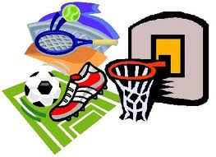

**AMATEUR** someone that does something as a hobby and not as a job.

**ATHLETICS** the practice of bodily exercises demanding strength and speed.

**BEAT** to do better than another in sports, games, race. To defeat

**BREAK A RECORD** to do it better than the previous sportsman/woman.

**BULL'S EYE** a small circular area at the centre of a target or dartboard.

**CAST** to throw

**CHAMPIONSHIP** a competition held to find the champion, the best that time.

**CLUB** a society of people who join together for a certain purpose, sport.

**COACH** trainer.

**COMPETE** to take part in a game with an intention to win.

**CONTESTANT** someone competing in a contest.

**COURT** an area especially prepared and marked for ball games (squash, tennis)

**COURSE** a piece of land where a particular sport is played or where races are held.

**DEFEAT** to beat. To win a victory over a person or group. The condition of losing.

**DOPE** an illegal medicine or drug to improve one's ability, speed, strength.

**DOUBLES** a match played between two pairs of players.

**DRAW** to end a game without either side winning.

**FACILITIES**  the equipment, buildings, services, etc, provided for a particular sports.

**FAN** a very queen follower, especially of a sport, team or person.

**FIELD** an open area where a game is played. Pitch

**FOUL** an act that is against the rules in sport.

**GROUND** a piece of land used for a particular purpose, often games: football,

cricket

**GYMNASTICS** the art of training the body by means of certain exercises

**HIT** to strike with something.

**HOOLIGAN** a noisy, rough person who causes trouble by fighting, breaking things,...

**IMPLEMENT** a tool or piece of equipment

**INDOOR** sth. which is done inside a building. Indoors (adverb)

**KEEP FIT** to keep one healthy and strong.

**LAP** a trip once round the track or over the distance.

**LEAGUE** a group of sports clubs or players that play matches amongst themselves.

**LOVE** a score of nothing in tennis.

**MATCH** a game or sports event where teams or people compete

**MISS** to fail to hit, catch, touch, hear, see (sth. or someone)

**NIL** a total of no points, marks, in sports such as football, rugby or hockey.

**OUTDOOR** happening, done or used in the open air. Outdoors (adverb)

**PITCH** a special field/area on which certain games are played: football, cricket...

**POOLS** a type of gambling to win money by guessing the results of matches.

**RANGE** a place where people practise shooting at targets

**REFEREE** a judge in charge of a sports match or contest. To referee.

**RESULT** **IN** to have as a result cause.

**RING** a closed central place where certain sports take place.

**RINK**  a special prepared and marked surface for skating, ice-skating.

**ROUND**  a set of games in a particular competition (golf). A period of time (boxing)

**RUNNER-UP** finish in second place in a competition. Many people can be runners-up.

**SCORE** the number of points, goals, etc, scored in a sport, game or competition.

**SHOOT** to quick the ball hard at the goal of another team.

**SIDE** a sports team.

**SINGLES** a match with one player against one (tennis).

**SPECTATORS** people who watch something, especially a sporting event.

**STRIVE** to make a great effort for sth. , usually over a long period of time.

**SUPPORTER** a fan, a follower.

**TIE** an equality of results. To be equal to an opponent in a competition.

**TOSS A COIN** to throw a coin into the air in order to make a decision.

**TRACK** an area in which people, vehicles, can race, especially for athletics.

**UMPIRE** referee, judge. To umpire = to referee

**VIEWERS** someone who looks something, especially on TV.