Plan dela za 6.a : četrtek, 16.04.2020
E-mail: mateja.arh@oskoroskabela.si
BODITE ZDRAVI!!!

- UVODNA MOTIVACIJA:
► razmisli, kako rečemo četrtek po angleško in kako mesec april. Potem na glas izgovori vse dneve v tednu in vse mesece v letu.
►nadaljuj z nalogami 14 in 15 v DZ-ju na str. 74 – 75. = ponovitev dnevov.

- UTRJEVANJE:
►s pomočjo rešitev utrjuj snov iz prejšnje ure. Rešitve najdeš na koncu navodil.
► glede na pravila uporabe HAVE ali HAVE GOT v zvezku, reši nalogo 12 in 13 v DZ-ju na str. 73 – 74.
► https://www.bookwidgets.com/play/4MA4E6?teacher_id=6599909971066880 ( nalogo, ki jo najdeš na tej spletni povezavi, prepiši v zvezek in jo reši. Naslov: exercise)

- REŠITVE:
► DZ str. 73 / naloga 11
1 Peggy has ballet in the afternoon.
2 Anna hasn't got a sister.
3 I have a shower in the evening.
4 Do you have swimming today?
5 When does Anna have school?
6 How many brothers have you got?
7 All my friends have got dogs.
8 Jane doesn't have breakfast at work.
9 I can help you. I have a lot of time for you.
10 My sister has got very beautiful long hair.

► UČB. Str. 80 / naloga 7
HAVE / HAS | HAVE GOT / HAS GOT
a sandwich | a car
breakfast | two children
a cup of tea | long hair
a shower | two sisters
 | a cat
 | a bike

► spletna naloga še v tiskani obliki ( 2 točka – utrjevanje)

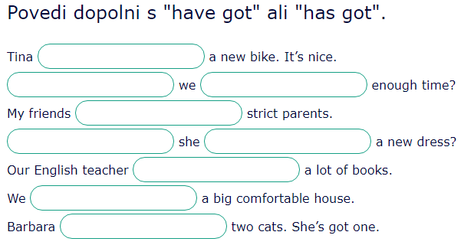

HAVE FUN !!!

