Navodilo za delo – TJA 8, TOR 14. 4.

Upam, da ste preživeli lep podaljšan vikend in da se veselite novih izzivov, ki vam jih pripravljamo za ta teden

- Vajo za ogrevanje naredi kdor želi.

Prejšnjo uro si v zvezek napisal 6 vprašanj (name, age, figure, …), nato pa si nekoga intervjuval in odgovore zapisal. Ker se bojim, da bom pozabila, kako izgledate, mi pošljite svoj opis – direktne odgovore na tista vprašanja.

Moj opis je takle:
My name is Tina. I am pretty young – I'm in my thirties. I am of average height – I'm 166 cm tall. I'm slim. I think I weigh around 54 kg (I don't have a scale at home). My eyes are green brown. My hair is short, straight and red. I like my manicured nails.

- V zvezek zapiši naslov Character, datum 14. 4., vprašanji iz okvirčka ter besede in vaje iz učnega lista.

Učni list je na naslednjih 2 straneh (če imaš možnost, ga lahko tudi natisneš, ampak potem rešenega prilepi v zvezek).

Zraven neznanih besed napiši prevod.
Reši obe vaji na UL (nasprotja, odg. na vprašanja).

Po značaju vprašaš:
What are you like?
What is he/she like?

Odgovor:
I am friendly, but shy.
He/She is nice and easy going.

Personality Adjectives
I’m not nosy at all .
I'm quite shy.
What are you like?

NOT AT ALL A BIT QUITE RATHER VERY EXTREMELY

calm /easy going / relaxed | serious | 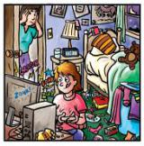  disorganised/ untidy/ messy | bossy
confident / brave / adveturous | lazy | 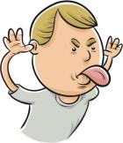  rude / impolite /  bad mannered | noisy
polite /  well manered | stingy / mean / selfish | clever / smart/ intelligent / wise | hardworking
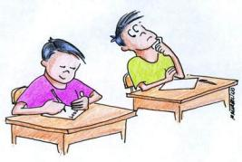  dishonest | sporty / active / lively | funny | 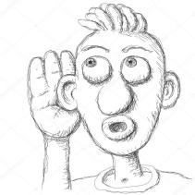  nosy
boring | nervous | 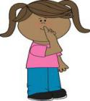  quiet | impatient /  bad tempered
mean / cruel | creative / artistic | nice / frienldy | honest / trustworthy
generous | silly / foolish / daft | 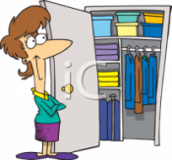  organized / tidy | shy / timid /  cautious

Personality adjectives

- Write the opposites (nasprotja):

- confident _______________
- lazy _______________
- polite _______________
- cruel _______________
- tidy _______________
- silly _______________
- quiet _______________
- nervous _______________
- honest _______________
- selfish _______________

- Answer the questions:

- What are you like?
___________________________________________________________________

- What do you like doing in your free time?
___________________________________________________________________

- What are you good at?
___________________________________________________________________

- What are you bad at?
___________________________________________________________________

- What are you frightened of?
___________________________________________________________________

- What can you do better this year?
___________________________________________________________________

- What’s your favourite class at school? Why?
___________________________________________________________________

- What type of music are you into? Why?
___________________________________________________________________

- Which famous person do you like? Why?
___________________________________________________________________

- What do you like and dislike about school?
___________________________________________________________________

- What are you really looking forward to this summer?
___________________________________________________________________

- What do you hope to do next year?
___________________________________________________________________

