**Navodilo za delo v SRE 15. 4.**

1. Najprej **preglej** in popravi vaje U 82/1b, U 83/2a ter DZ 74+75/13-16.

U 82/1b

1.Anna's parents leave home.

2.Anna's father drives too fast.

3.Mrs Lovelock sees her daughter in the street.

4.Mr Lovelock stops the car.

5.Anna and her parents go home together.

U 83/2a

Ana has ballet only on Friday. – F, Anna has ballet on Monday and Friday.

She goes riding on Tuesday and Saturday. – T

She sings in the school choir on Friday. – T

She is free on Wednesday. – F, She has piano lessons on Wednesday.

She has drama club and riding on Thursday. – F, She doesn’t have riding on Thursday.

She has no time for riding on Monday. – T

We don’t know what she has on Sundays. – T

She has swimming from Monday to Sunday. – F, She only has swimming on Monday.

DZ

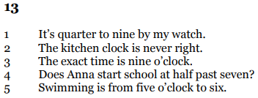

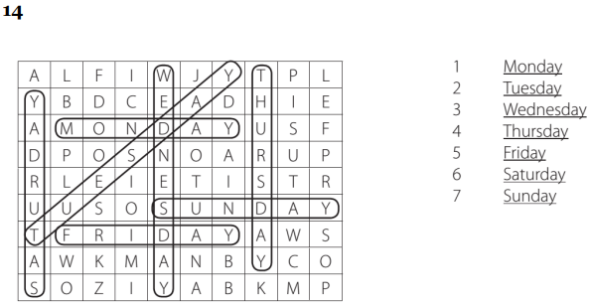

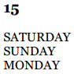 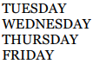 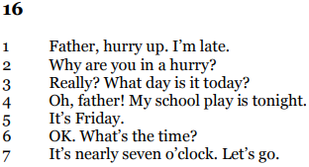

1. Danes in v petek osvežiš znanje o vprašalnicah in vprašanjih.

Za ogrevanje si **poglej** tale **video**: <https://www.youtube.com/watch?v=Wwfhpm1xjF8>

1. **V zvezek** zapiši naslov, datum in spodnjo razlago.

**Question words = Vprašalnice 15. 4.**

|  |
| --- |
| WHERE – kje, kam |
| WHAT - kaj |
| WHO - kdo |
| WHAT - kaj |
| WHEN - kdaj |
| WHY - zakaj |

**VRSTNI RED:**

When do you have breakfast?

Vprašalnica + do/does + osebek + glagol + (ostali podatki)?

1. **Reši** spletno nalogo <https://www.liveworksheets.com/worksheets/en/English_as_a_Second_Language_(ESL)/Wh_questions/Who,_what,_where,_when,_why_tg30366rb>
2. Spletno nalogo **prepiši v zvezek** (celo vprašanje in odgovor).

**Podčrtaj rešitve** (vprašalnice).

**Slikaj** in mi **pošlji** na mail [tina.rajhman@oskoroskabela.si](mailto:tina.rajhman@oskoroskabela.si).

