**Navodilo za delo v TOR 4. 5.**

1. V zvezku **preglej** tabelo.

|  |  |
| --- | --- |
| **Zapis** | **Izgovorjava** |
| *30th September* | *the thirtieth of September* |
| **15th March** | the fifteenth of March |
| 22nd December | **the twenty-second of December** |
| **10th July** | the tenth of July |
| 18th May | **the eighteenth of May** |
| **20th February** | the twentieth of February |
| 1st January | **the first of January** |
| **13th April** | the thirteenth of April |
| 3rd October | **the third of October** |
| **12th November** | the twelfth of November |

1. **Preglej** vaje DZ 81/27-29.

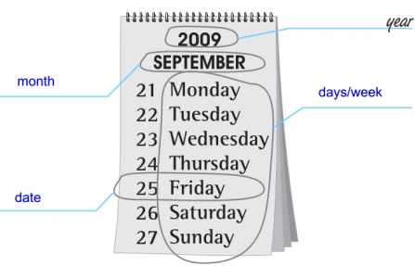 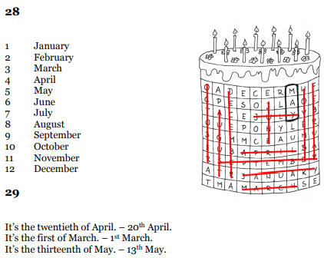

1. **Reši** vaje **DZ 82+83/30-34**.
2. Poglej besedilo v U 91+92. **V zvezek** napiši spodnji naslov, datum in primer.

**The Aztec horoskope = Azteški horoskop** 6. 5.

Our teacher's birthday is on 7th July, so her Aztec sign is a dog. She likes parties. She is also a good friend. She always helps when somebody needs her. English is her favourite subject.

* V U 91+92 poišči svoj rojstni datum in napiši podoben opis zase. Slikaj in pošlji.
* Če želiš, reši vaje DZ 83+84/35abc (lahko samo eno od A/B/C, ali pa vse).