**Navodilo za delo v SRE 13. 5.**

1. Za začetek **poslušaj in poglej** naslovno pesem iz izvirnega filma o Piki Nogavički <https://www.youtube.com/watch?v=1mOGeAM7KME> 😊
2. **Preglej** vajo **DZ 86+87**. Pazi: vsi glagoli pri Piki imajo na koncu -s: turns, goes, …

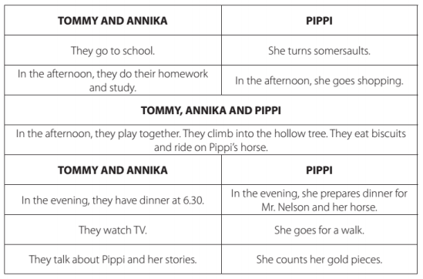

1. Še enkrat **naglas preberi** zgodbo U 97+98.
2. **V zvezek** napiši spodnji **naslov** in današnji **datum**. Čakata te 2 vaji (ta in naslednja stran) – slikaj in pošlji.



1. **Prepiši** vprašanja in jih **dopolni** z »Do« ali »Does«. **Odgovori** na daljši (vljuden) način, torej ne samo »Yes/No«. Pomagaj si s primeri U 99/2c.
2. _______ Tommy and Annika's father turn on the radio in the morning?
3. _______ Tommy and Annika wake up Pippi?
4. _______ Pippi still sleep at 7 o'clock?
5. _______ Pippi go to school?
6. _______ Tommy and Annika like P.E.?
7. _______ Pippi work in the garden?
8. _______ Pippi, Tommy and Annika have fun?
9. _______ the children ride a bike?
10. _______ Pippi go to bed at midnight?
11. **Prepiši** vprašanja in jih **dopolni** z vprašalnicami »when / what time«, »what«, »who«, »why«, »where«. **Odgovori** s točnimi podatki.
12. ____________ does Pippi do at 8 a.m.?
13. ____________ do Tommy and Annika go to school?
14. ____________ does Pippi go in the afternoon?
15. ____________ do the children have fun? (vprašaj po razlogu)
16. ____________ prepares dinner for Mr Nelson and the horse?
17. ____________ are Tommy and Annika at home at 6:30?
18. ____________ is Pippi at 8 p.m.?
19. ____________ do Tommy and Annika go at 8 o’clock?
20. ____________ sleeps at 10 p.m.?