Načrt dela za 8.abc/1. skupina: torek, 14.04.2020
OSTANITE ZDRAVI!
Učiteljica Mateja Arh
E-mail: mateja.arh@oskoroskabela.si

- MISEL DNEVA: ‚‘Verjamem, da je edini pogum, ki ga kdorkoli potrebuje, pogum, da sledi svojim sanjam.‘‘

- REŠITVE: the interview

Ask your family member or a friend the following questions:
NAME: What's your name? His/Her name is….
AGE: Are you old or young? He/She is….
How old are you? He/She is…..years old. or. He/She is…..
FIGURE: Are you tall or short? He/She is …
How tall are you? He/She is …tall.
Are you slim or fat? He/She is …
How much do you weigh? He/She weighs …kg.
EYES: What colour are your eyes? His/Her eyes are…
HAIR: What is your hair like? His/Her hair is…
What colour hair have you got? His/Her hair is…/ The colour of his/her hair is…
? : What do you like about yourself? He/She likes …

- NOVA SNOV: DESCRIBING SOMEONE’S CHARACTER – OPIS ZNAČAJA
► naučili smo se že, kako vprašamo po zunanjem izgledu. ( What do you look like?/ What does he/she look like?)
► zapišemo nov naslov v zvezek: DESCRIBING SOMEONE’S CHARACTER – OPIS ZNAČAJA
► zapišemo vprašalnici, s katerimi sprašujemo po značaju
WHAT ARE YOU LIKE? – Kakšen si po značaju?
WHAT IS HE/SHE LIKE? – Kakšen je on/ona po značaju?
► poglej slike, ki opisujejo značaj. Izpiši pridevnike ( adjectives) v zvezek in jih prevedi. Lahko slike tudi fotokopiraš in jih zalepiš v zvezek.

Personality Adjectives
I’M NOT NOSY AT ALL .

I’M QUITE SHY.
NOT AT ALL A BIT QUITE RATHER VERY EXTREMELY
WHAT ARE YOU LIKE?

CALM /EASY GOING/ RELAXED | SERIOUS | 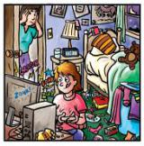  DISORGANISED/ UNTIDY/ MESSY | BOSSY
CONFIDENT / BRAVE/ ADVENTUROUS | LAZY | RUDE / IMPOLITE/ BAD MANNERED | NOISY
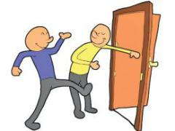  POLITE /  WELL MANNERED | STINGY / MEAN /SELFISH | CLEVER/ SMART/ INTELLIGENT / WISE | HARDWORKING
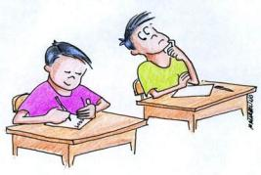  DISHONEST | SPORTY/ ACTIVE/LIVELY | FUNNY | 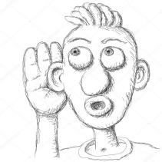  NOSY
BORING | NERVOUS | 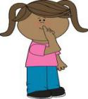  QUIET | IMPATIENT/  BAD TEMPERED
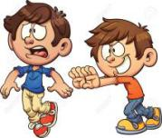  MEAN/CRUEL | CREATIVE/ ARTISTIC | 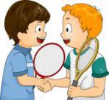  NICE/ FRIENDLY | HONEST/ TRUSTWORTHYY
GENEROUS | SILLY / FOOLISH/ DAFT | 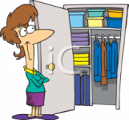  ORGANZED/ TIDY | SHY/ TIMID/  CAUTIOUS
CAN YOU THINK OF ANY MORE ADJECTIVES TO DESCRIBE SOMEONE’S PERSONALITY?

Personality adjectives

► Write the opposites/ Zapiši nasprotja teh pridevnikov v zvezek.
- confident _______________
- lazy _______________
- polite _______________
- cruel _______________
- tidy _______________
- silly _______________
- quiet _______________
- nervous _______________
- honest _______________
- selfish _______________
Getting to Know You

► Answer the questions/Vprašanja prepiši v zvezek in na njih odgovori za sebe.
What are you like?
What do you like doing in your free time?
What are you good at?
What are you bad at?
What are you frightened of?
What can you do better this year?
What’s your favourite class at school? Why?
What type of music are you into? Why?
Which famous person do you like? Why?
What do you like and dislike about autumn?
What are you really looking forward to this year?
What do you hope to do this year?
HAVE FUN!!!

