TJA 7.b – PON 20. 4.

- Najprej preglej in po potrebi popravi UL od četrtka. Večino ste imeli kar prav

1. naloga
Your house is smaller than ours / smaller than our house
David is shorter than Bill.
My marks are better than Jack’s.
My bike is faster than yours / is faster than my bike.

2. naloga
This was the cheapest (cheap) watch that they had in the shop.
The blue whale is the largest (large) of all the animals.
The oldest (old) university in the world is in Morocco.
I think that was one of the worst (bad) days of my life.

3. naloga
Mandy is a good pupil. She’s the best pupil in our class. She’s much better than Jane. (good)
Is John a bad football player? Yes, he’s the worst player in our team. He’s even worse than little Bobby. (bad)
New York is a big city. It’s the biggest city in the USA. (big)
Storžič is a high mountain, but Triglav is the highest in Slovenia. (high)
Is the Soča longer than the Sava? (long)
Which is the shortest month in the year? (short)
This year the weather is worse than last year. (bad)
Wine is cheaper in Slovenia than in GB. (cheap)
He thinks he’s the best pupil in the class. (good)
There are better shops in London than in other towns. (good)
Bananas are sweeter than oranges. (sweet)
This is the shortest story in the book. (short)
Paul’s homework is the worst of all. (bad)

- Danes bereš in poslušaš besedilo U str. 100.
Besedilo lahko poslušaš in prebereš 2x.
https://touchstone.si/audio/ts7/100_(Great)_Britain_versus_Canada.mp3

- Pri 3. poslušanju ne glej besedila, ampak ustrezno sliko (spodaj) – kaj je omenjeno.

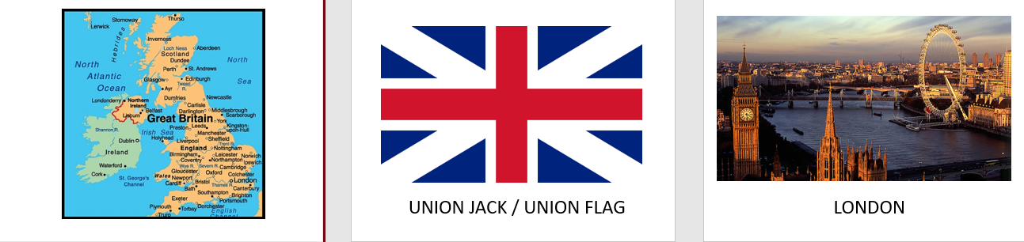
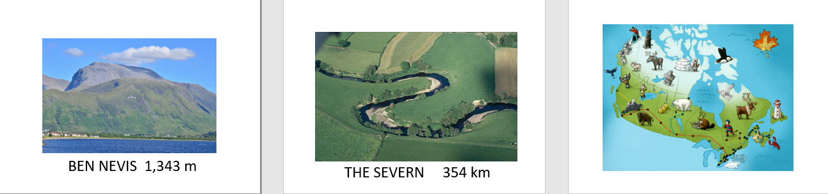
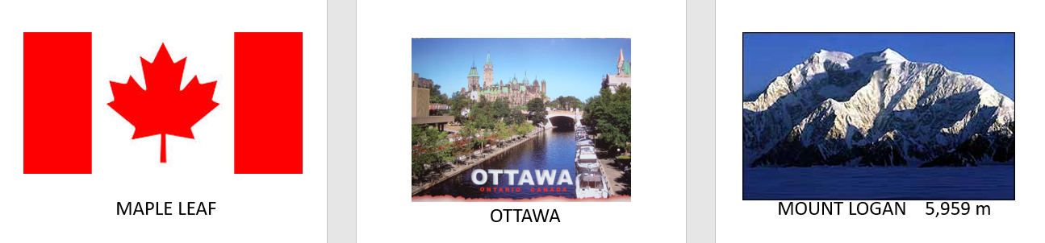
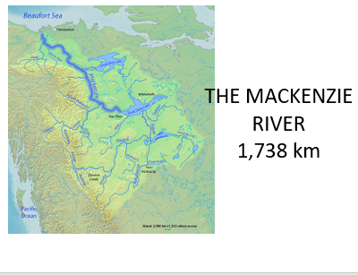

- V zvezek prepiši naslov, datum in snov.

GB VERSUS CANADA 20. 4.

Prepiši besede v zvezek in jih prevedi v slovenščino.

GLOBETROTTER | FOREST
IMPRESSION | PRAIRIE
A COIN  OUTGOING | TUNDRA  EVERGREEN
MANNER | INLAND
COUNTRYSIDE | VAST FARMLANDS
LANDSCAPE | SEVERE

Prepiši vprašanja v zvezek in nanja odgovori.

- Where does Mrs Globetrotter come from?
- What does she like doing?
- How many km has she travelled so far?
- What is she talking about on a TV show?
- What do you notice first in GB?
- What are the British like?
- Why is it easier to travel in Britain?
- How high is the highest mountain in Britain?
- What`s it called?
- What is British countryside like?
- What kinds of landscape has Canada got?
- What is the climate in Canada like?
- Is Canadian food worse than British? Why?

