TOREK, 12. 5. 2020

TJA 9 (skupina Ahačič)

Verjamem, da vam oblika trpnika ne dela več težav.

Še enkrat ponovimo razliko med tvornim in trpnim načinom. Naredi zapis v zvezek; naslov je Active to Passive.

ACTIVE (tvorni način)
She washes her clothes.
OSEBEK JE VRŠILEC DEJANJA: Kaj ona dela? – Pere oblačila.
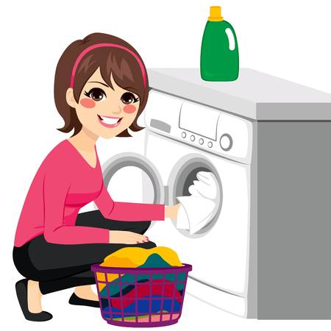

PASSIVE (trpni način)
Her clothes are washed.
OSEBEK NI VRŠILEC DEJANJA: Kaj se dogaja? – Oblačila so oprana.

POMEMBNO: PREDMET tvorne povedi postane OSEBEK trpne povedi.

1. Spodnje povedi pretvori v trpnik (Passive). Nalogo fotografiraj ali natipkaj in mi jo pošlji.
Glej primer, ki je že rešen.

PRIMER: He opens the door. The door is opened.
- We set the table.
- She pays a lot of money.
- I draw a picture.
- They wear blue shoes.
- They don't help you.
- He doesn't open the book.
- You do not write the letter.
- This bird makes a nest.
- We play tennis twice a week.
- They publish hundreds of books every year.
- Water covers 71 % of the planet.
- Ann answers the telephone at the company.
- They shuffle the snow every winter.
- We use this room only on special occasions.

Odgovori še na tole vprašanje in mi pošlji svoj odgovor :
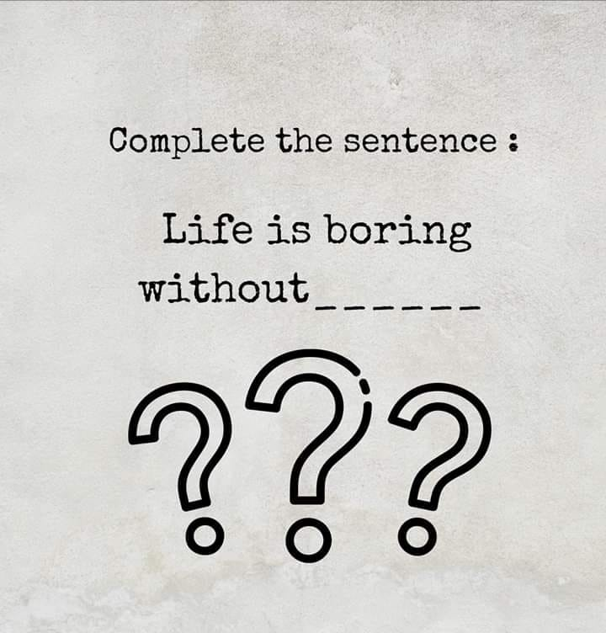
My answer:
Life is boring without LVE.

