TOREK, 14. 4. 2020

TJA 9 (skupina Ahačič)

Danes bomo pogledali različne vrste TV-oddaj.

Pripravila sem ti seznam besed, ki jih boš prepisal(a) v zvezek pod naslov TV programmes. Besede prevedi v slovenščino.
V pomoč naj ti bodo posnetki, ki prikazujejo posamezno vrsto oddaje. Če potrebuješ dodatno pomoč, pa si pomagaj s slovarjem.

CARTOONS
https://www.youtube.com/watch?v=PrNI1m5jBC4&t=65s
NEWS & WEATHER
https://www.youtube.com/watch?v=At3sd_8oJMc
https://www.youtube.com/watch?v=t2aWyRtnRCg
SITCOMS
https://www.youtube.com/watch?v=52771yKS3As
CHAT SHOWS
https://www.youtube.com/watch?v=0OXjCR3Uu0A
FILMS
https://www.youtube.com/watch?v=z02Ie8wKKRg
DOCUMENTARIES
https://www.youtube.com/watch?v=TjtrdpSwEUY
POLICE SERIES
https://www.youtube.com/watch?v=mR3jnW2kcUs
SERIALS
https://www.youtube.com/watch?v=NUT07eZoXPw
SOAPS
https://www.youtube.com/watch?v=UsbjcWAFquw
SPORTS
https://video.eurosport.com/alpine-skiing/world-championships/2018-2019/absolutely-brilliant-ilka-stuhec-with-gold-medal-run_vid1162440/video.shtml
MUSIC
https://www.youtube.com/watch?v=JxxyTOIPCZc
REALITY SHOW
https://www.youtube.com/watch?v=RYGTOqkLBOo
STUDIO/PANEL DISCUSSIONS
https://www.youtube.com/watch?v=yX5EJf4R77s
EDUCATIONAL PRGRAMMES
https://www.youtube.com/watch?v=HzwFgqUi74k
CHURCH SERVICE
https://www.youtube.com/watch?v=a1TEjzAnGaE

V zvezek naredi še ti dve nalogi:

A) Izberi pravilen odgovor in poved zapiši v zvezek.

1 ‘ I’m watching ___!’ ‘Oh, so that’s why you’re laughing loudly!’
a) a police drama b) the news c) a comedy

2 My dad makes ___ about birds for a TV company.
a) documentaries b) westerns c) romcoms

3 Grandma watches her favourite ___ every day. She never misses any episodes.
a) weather forecast b) soap opera c) the news

4 Who wants To Be a Millionaire is a kind of ___.
a) music programmes b) reality shows c) quiz shows

5 I love ___. Tom and Jerry are my favourite characters.
a) cartoons b) romantic comedies c) horror films

B) Prepiši opis oddaje in skušaj najti pravo besedo.

1 A programme where you try to answer questions.: _______

2 A story about the lives of a group of people, that is on TV every day or several times each week.: __________

3 Words that tell people about things that have just happened.: _______

4 A film about true things.: _______

5 A film about cowboys in the west of the USA.: _______

6 A funny play or film.: _______

7 Words on TV that tell you what the weather will be like.: ________

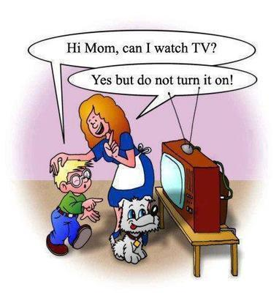
8 A film made with drawings, not pictures of real people.: ________

9 A film that shows frightening things: ______

