PETEK, 10. 4. 2020

TJA 8 (skupina Ahačič: Anan, Ana, Matic, Gaj, Ermin, Kristjan, Anja, Ema, Matija, Jaka, Eldar, Anel)

Preglejte nalogi v delovnem zvezku:
DZ str. 80/46, 47

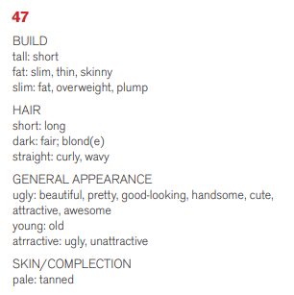
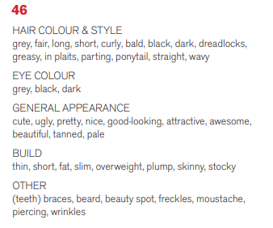

Današnjo uro angleščine izvedi v naravi:
na balkonu, na terasi, na vrtu, na travniku …

1. INTERVJU
Danes boste naredili intervju s svojim prijateljem, sošolcem ali družinskim članom.
V zvezek boste napisali naslov Personal appearance interview. V pomoč so vam spodnja vprašanja. Odgovori so lahko kratki.
NAME

What’s your name?

AGE
Are you old or young?

How old are you?

FIGURE

Are you tall or short?

How tall are you?

Are you slim or fat?
How much do you weigh?

EYES

What colour are your eyes?
And
Monday!

HAIR

What is your hair like?

What colour hair have you got?
What do you like about yourself?

2. DELOVNI ZVEZEK
DZ str. 79/45ab

