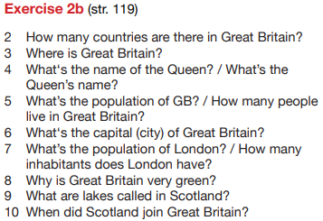
TJA 7.b – TOR 12. 5.

- Preveri rešitve vaj DZ 118+119/2ab.
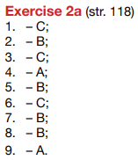

- Preberi besedila v U 115+116/1-3 (Extra reading).

- V zvezek prepiši vprašanja in napiši odgovore.

About Great Britain 12. 5.

- What does the name The British Isles refer to?
- Which countries does The United Kingdom consist of?
- What is the full name of The United Kingdom?
- Which countries are there in Great Britain?
- Which is the biggest country in Britain?
- What is the Union Jack?
- What does the English flag look like?
- What does the Scottish flag look like?
- What does the Irish flag look like?
- What is the national flower of England?
- What is the national flower of Northern Ireland?
- What is the national flower of Scotland?
- What are the national symbols of Wales?

- Tabela spodaj desno opisuje stereotipe (prepričanja o določeni skupini ljudi, ki nujno ne držijo). Stereotipe o Angležih zapiši v stavkih.

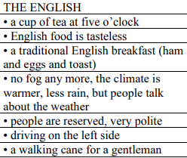
- The English drink a cup of tea at five o'clock.
- (nadaljuj sam)

