TJA 7.b – TOR 17. 3.

- v zvezek napiši naslov Romeo and Juliet in datum 17. 3.
- poišči in preberi obnovo tragedije v slovenščini
- oglej si zgodbo o Romeu in Juliji http://learnenglishkids.britishcouncil.org.cn/short-stories/romeo-and-juliet?page=1%2C0%2C0%2C2
- ob ogledu posnetka reši naloge na učnem listu – glej 2. stran teh navodil. Če imaš možnost, lahko list natisneš in nalepiš v zvezek, ni pa nujno.
- DN: ponovi nepravilne glagole

- Besede prepiši v zvezek in dodaj slovenske prevode. Pomagaj si s sličicami.

family | fight | love | angry | get married | drink
sleep | wake up | letter | dead | poison | knife

 |  | 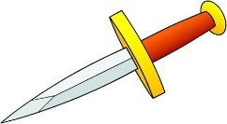 | 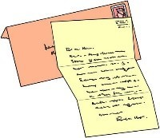
 | family

- Razvrsti dogodke kot si sledijo v zgodbi. V pravilnem zaporedju jih prepiši v zvezek.

_____ Romeo Montague and Juliet Capulet fall in love.

_____ Romeo kills Tybalt so the Prince of Verona sends him away.

_____ The Capulet family and the Montague family are always fighting.

_____ Romeo is so sad that he kills himself, then Juliet sees Romeo is dead and she kills herself.

_____ Romeo doesn’t get Friar Lawrence’s letter and thinks Juliet is dead.

_____ Tybalt, Juliet’s cousin, kills Mercutio, Romeo’s friend.
_____ The families are so sad that they agree not to fight any more.

_____ Juliet makes a plan with Friar Lawrence to drink a special drink and she pretend to be dead.

