TJA 7.b – Preglej in popravi.

REVISION on the Past Simple, large numbers, adjectives, countries Class 7

May 2020

1. Preberi sestavek o Novi Zelandiji (v prilogi – zadnja stran) ter reši nalogi A in B.

A) Ugotovi, ali so spodnje trditve pravilne T – true ali napačne F – false. Glej primer, ki je že rešen. 6/ ____

 | T | F
New Zealand is a big country. |  | X
New Zealand is as large as California. | X
There is a variety of countryside. | X
Queenstown is the capital of New Zealand. |  | X
Wellington is the largest city in New Zealand. |  | X
A part of Mount Cook is always covered in snow. | X
The inhabitants of New Zealand are called Kiwis. | X

B) Na kratko odgovori na vprašanja.
5/ ____
What’s the population of New Zealand? 4.5 million
What are the official languages? English and Maori.
What’s the name of their money? New Zealand dollar.
Why is New Zealand sometimes called a natural theme park? Because of its amazing geography.
Name three adventure sports you can do there.
Bungy jumping, hang-gliding, rafting.
Why is Aukland called the City of Sails? Because so many boats sail in the harbour.

2. S pomočjo podatkov v tabeli tvori smiselne povedi. Številke zapiši z besedo. Glej primer, ki je že rešen. 6/ _____

Jim | Lake Bohinj | the Drava | Mt Cook | Columbus - birth
1,54 cm | 45 m | 707 km | 3,754 m | 1451

a) Jim is one hundred and fifty-four cm tall.

b) Lake Bohinj is 45 m long.

c)_The Drava is 707 km long.

d) Mt Cook is 3,754 m high.

e) Columbus was born in 1451.

3. Dopolni razpredelnico z manjkajočo obliko pridevnika. 10/ _____

POSITIVE  (osnovnik) | COMPARATIVE  (primernik) | SUPERLATIVE  (presežnik) | OPPOSITE  (protipomenka)
far | further | the furthest | near
wet | wetter | the wettest | dry
wide | wider | the widest | narrow
shy | shier/shyer | the shiest/the shyest | brave
difficult | more difficult | the most difficult | easy

4. Dopolni povedi z ustrezno stopnjo pridevnika: osnovnik, primernik ali presežnik. Ne pozabi uporabiti than/the/as…as, kjer je to potrebno. 10/ _____

- The trip was more interesting than the last one. (interesting)
- She’s the most beautiful girl at our school. (beautiful)
- Your room is dirtier than my room. (dirty)
- I’m the youngest member of our family. (young)
- My sister isn’t taller than me. She’s shorter. (tall)
- It’s very windy today. (windy)
- Helen is the thinnest girl in our class. (thin)
- I don’t think we’ll have much sun today. The weather is getting worse (bad)
- A cheetah is faster than a lion. (fast)
- Which is heavier: lead or gold? (heavy)

5. Povedi napiši drugače. Ne uporabi več kot tri besede. Poved naj ima enak pomen kot napisan stavek.
5/ _____
0. English is easier than German. German isn’t as easy as English.

  - David isn’t as brave as Max. Max is less brave than David.

  - Josh is better at Maths than Nick. Nick isn’t as good at Maths as Joe.

  - Everything on the menu is cheaper than the steak. The steak is the most expensive thing on the menu.

  - Rebecca is 1.69 m and Sophie is 1.80 m. Sophie is taller than Rebecca.

5. I don’t know anyone who is smarter than you. You are the smartest person I know!

6. Vpiši manjkajoče besede (države, narodnosti, jeziki). Pazi na zapis besed. 6/ _____

- Tobias is from the Netherlands. He is Dutch.
- Astrid is from Finland. She is Finnish.
- Los Angeles is very Spanish in character.
- The first Olympic Games were in Greece.
- Pippi Longstocking is from Sweden.
- I love the sweet smell of this French perfume. I bought it in Paris.

7. Vpiši manjkajoče besede. 8/ _____

- Australia covers an AREA of 7,686,850 sq km and has a POPULATION of around 25 million people.
- The CAPITAL of the USA is Washington, DC.
- She is as beautiful as a PICTURE and he is as busy as a BEE.
- Her room is messy, but my room is always TIDY.
- Black Africans worked in America as SLAVES.
- How FAR is it from Ljubljana to Kranj? – About 20 km, I think.

8. Glagole v oklepaju postavi v navadni sedanjik (The Past Simple Tense). 10/ _____

- I moved (move) here nine years ago.
- I started (start) skating four years ago.
- He met (meet) her in June.
- You didn’t buy (not buy) the present yesterday.
- Mr Jones lived (live) here six months ago.
- I left (leave) that school four years ago.
- He began (begin) working in Ireland in 1999.
- Last year he taught (teach) children how to play the guitar.
- Did they see (they / see) Riverdance when they were in Ireland?
- He changed (change) his job in February and is now a policeman.

9. Zapiši vprašanja za podčrtane dele povedi. 5/ _____

- Was the hotel good/OK ? Yes, it was. The hotel was very good.

- Where did Pablo Picasso live ? Pablo Picasso lived in Spain.

- Why did Monica tidy up her bedroom ? Monica tidied up her bedroom because her mum insisted.

- When did he buy a new bike ? He bought a new bike last week

- What were they good at ? They were good at taking photographs.

10. PISNI SESTAVEK.

My classmates & me

Piši o sebi in sošolcih:

- Napiši/Primerjaj, kdo je naj (višji, starejši, mlajši ...) v razredu,
- Napiši/Primerjaj, kdo ima naj (daljše lase, težjo torbo ...) v razredu,
- Primerjaj sebe s posameznimi sošolci (5 primerjav).

Uporabi vsaj 10 različnih pridevnikov (v osnovniku primerniku in/ali presežniku).

_________________________________________________________________________________________________________________________________________________________________________________________________________________________________
_________________________________________________________________________________________________________________________________________________________________________________________________________________________________
_________________________________________________________________________________________________________________________________________________________________________________________________________________________________
_________________________________________________________________________________________________________________________________________________________________________________________________________________________________
_________________________________________________________________________________________________________________________________________________________________________________________________________________________________
_________________________________________________________________________________________________________________________________________________________________________________________________________________________________

Vsebina: 3/ _____ Besedišče: 3/ _____ Slovnica: 3/ _____

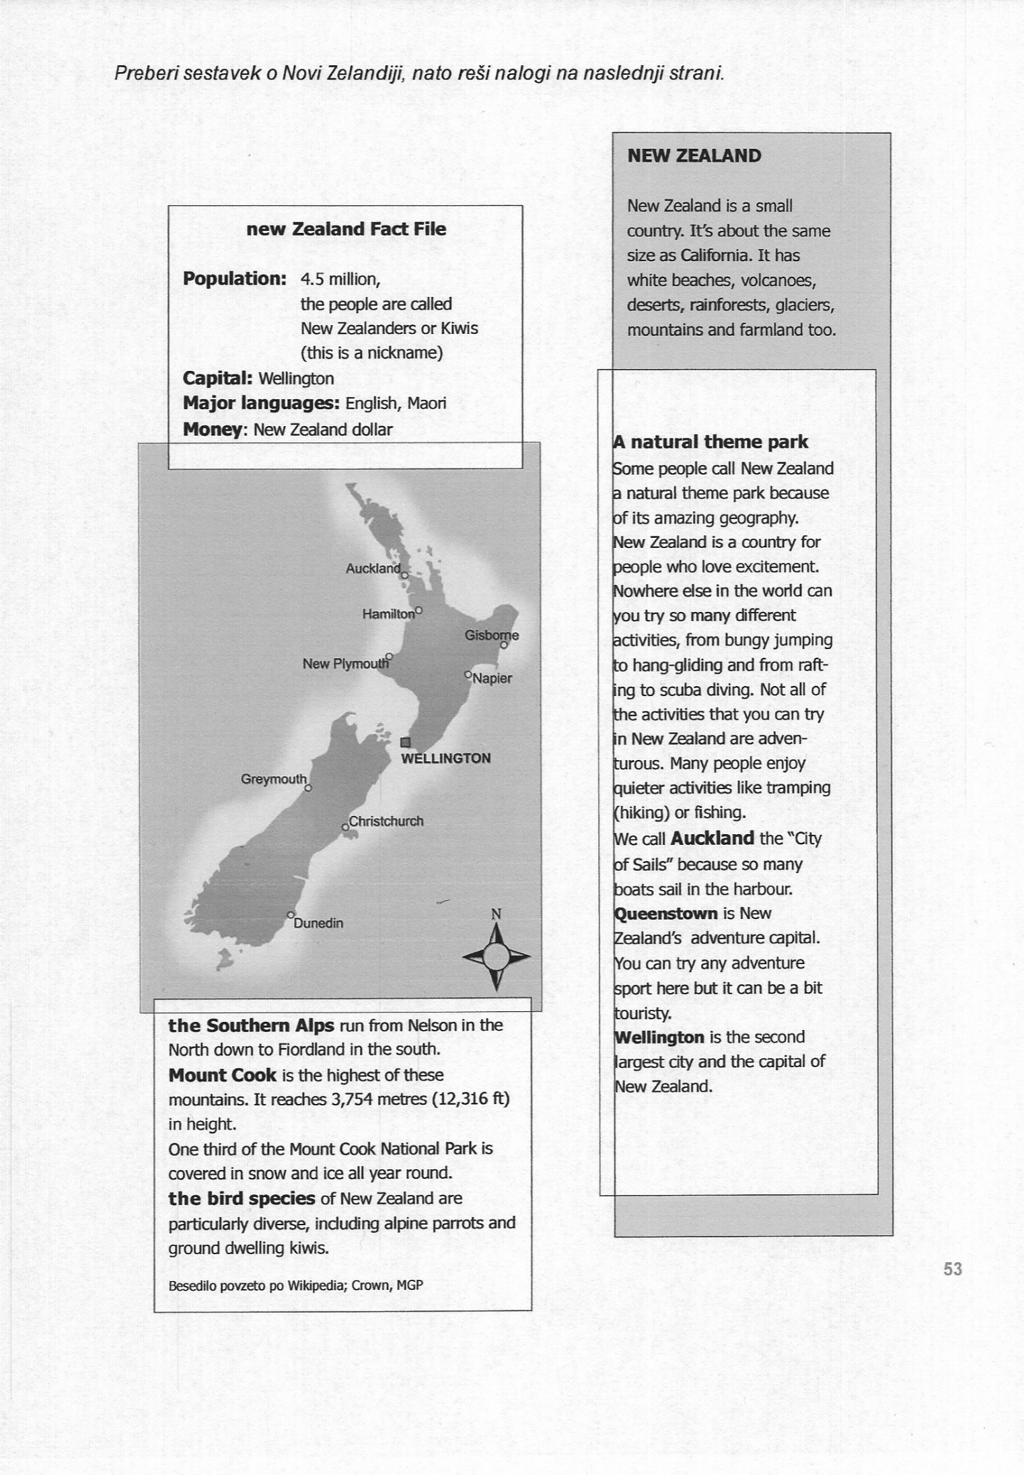
PRILOGA: BRALNO RAZUMEVANJE

