TJA 7.b – TOR 21. 4.

- Najprej preglej in po potrebi popravi včerajšnjo snov v zvezku.

GB VERSUS CANADA 20. 4.

GLOBETROTTER = svetovni popotnik | FOREST = gozd
IMPRESSION = vtis | PRAIRIE = prerija
A COIN = kovanec  OUTGOING = družaben | TUNDRA = tundra  EVERGREEN = zimzelen
MANNER = način | INLAND = notranjost celine
COUNTRYSIDE = podeželje | VAST FARMLANDS = velike kmetijske površine
LANDSCAPE = pokrajina | SEVERE = oster

- Where does Mrs Globetrotter come from? Ottawa, Canada.
- What does she like doing? She likes travelling.
- How many km has she travelled so far? 2.6 million kilometres.
- What is she talking about on a TV show? About her impressions of Britain.
- What do you notice first in GB? The coins are heavier, the buildings are redder and the grass is greener.
- What are the British like? They are quieter than the Canadians and not very outgoing, but they behave better.
- Why is it easier to travel in Britain? Because Britain is a lot smaller than Canada.
- How high is the highest mountain in Britain? 1,343 metres.
- What`s it called? Ben Nevis.
- What is British countryside like? Beautiful.
- What kinds of landscape has Canada got? It has many different kinds of landscape like forests, prairies, tundra and vast farmlands.
- What is the climate in Canada like? It’s much more severe than in Britain.
- Is Canadian food worse than British? Why? No, Canadian food is better, also beer and coffee.

- Če je treba, lahko še enkrat prebereš besedilo v U 100.
V zvezek napiši oznako U 101/3 in zapiši to vajo.
Primerjaj naslednje stvari v Kanadi in Veliki Britaniji:

Pomagaj si s tabelo na naslednji strani teh navodil.
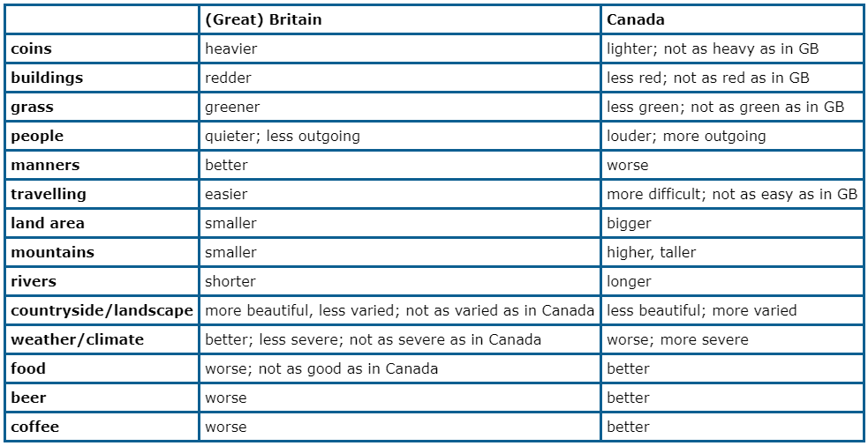
Prepiši primere in nadaljuj sam (PAZI ali je beseda v ednini ali množini IS / ARE):
- The coins in Britain are heavier.
- The buildings in Britain are redder.
- The grass in Britain is … (dokončaj stavek in naredi vse primere do konca tabele)

- Reši vaji DZ 108/14+15.

