TJA 7.b – TOR 5. 5.

Nadaljuj zapis v zvezek (včeraj naloge 1-3, danes pa naloge 4 in 5).

4. Primerjaj risane junake in pri tem uporabi vse pridevnike:
- tall, young, slow, poor, shy, happy, short, thin, old, nice, rich, strong, pretty, fast, heavy, popular
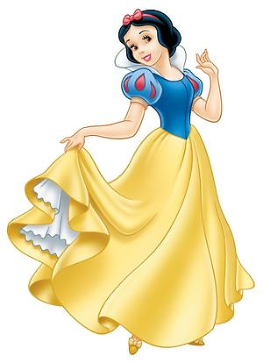
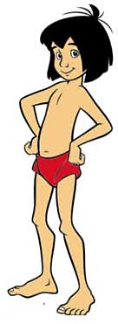
OBELIX ALICE MOWGLI SNOW WHITE
37 years old 11 years old 9 years old 17 years old
112 kilos 45 kilos 33 kilos 60 kilos
1.80 cm 1.50 cm 1.35 cm 1.73 cm

- Obelix is richer than Mowgli but Alice is the richest.
- (nadaljuj sam)

5. Povedi dopolni z ustrezno obliko pridevnika: osnovnik, primernik, presežnik.

1. Her eyes are (grey) _____________ than mine.
2. He was the (fat) _____________ man in the village.
3. As he went on, the box became (heavy) ___________ and (heavy) ___________.
4. My sister is the (tall) _____________ girl in her class.
5. Who is the (lazy) _____________ student in your group?
6. It is autumn. Every day the air becomes (cold) _____________, the leaves (red) _____________.
7. This is the (beautiful) _____________ view I have seen in my life.
8. Your handwriting is now (good) _____________ than it was last year
9. Oil is (light) _____________ than water.

