TJA 7.b – TOR 7. 4.

- Danes najprej preglej zadnjo vajo v zvezku od včeraj – iz U 95/5ab.

- 572 = five hundred and seventy-two
- 962 = nine hundred and sixty-two
- 102 = a/one hundred and two
- 1,542 = a/one thousand, five hundred and forty-two
- 312 = three hundred and twelve
- 744 = seven hundred and forty-four
- 289 = two hundred and eighty-nine
- 3,465 = three thousand, four hundred and sixty-five
- 7,423 = seven thousand, four hundred and twenty-three
- 4,226 = four thousand, two hundred and twenty-six
- 8,732 = eight thousand, seven hundred and thirty-two
- 9,999 = nine thousand, nine hundred and ninety-nine
- 2,865 = two thousand, eight hundred and sixty-five

- Odpri U na str. 96 in zvezek.

- Napiši naslov Road distances in Slovenia in datum 7. 4.
- Napiši oznako U 96/7.

- Prepiši primer.
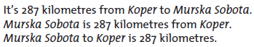

- Napiši še za naslednje razdalje. Vedno na vse 3 načine.
- Jesenice-Bled
- Jesenice-Kranj
- Jesenice-Ljubljana

- Prepiši primer.
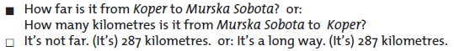
- Napiši tak pogovor še za razdaljo Jesenice-Portorož. Odgovor, ali je to zate blizu ali daleč, prepuščam tebi

- Napiši oznako U 96/8.

- Prepiši primer.

- Tako kot kaže primer napiši še vprašanje in odgovor (s številko in v oklepaju z besedo) za naslednje vrhove: Ben Nevis, Etna, Mount Everest.

- Reši vaje v DZ 102+103/4+5a.

