**PONEDELJEK, 11. 5. 2020**

TJA 7. A

**OPOMNIK ZA OCENJEVANJE**

11. 5. 2020 ob 9.00 (Rok, Anja, Jakob F., Leon)

<https://us04web.zoom.us/j/71081642882> Meeting ID: 710 8164 2882

12. 5. 2020 ob 9.00 (Alin, Manca, Dejan, Taj)

<https://us04web.zoom.us/j/76884827885> Meeting ID: 768 8482 7885

14. 5. 2020 ob 9.00 (Lejla, Tina, Vita, Ana)

<https://us04web.zoom.us/j/78327508337> Meeting ID: 783 2750 8337

**Odgovori na vprašanja:**

1. No, it isn't.
2. No. It's rich./It's the richest.
3. 50./Fifty.
4. Washington
5. In the White House.
6. Donald Trump.
7. Los Angeles, Chicago, New York, Philadelphia, Detroit, Miami …
8. The film capital of the world.
9. Because it is located near Mexico.
10. English.
11. Spanish.
12. Baseball.
13. Independence Day (4th of July)
14. Because of its countryside. Because of the variety of nationalities.
15. Native Americans = Indians.
16. From all over the world: from England, Spain, Scotland, Ireland, the Netherlands, France, Italy, Germany.
17. From Africa.
18. Slaves.

Danes in jutri boš spoznal(a) še eno angleško govorečo državo, in sicer Veliko Britanijo (Great Britain).

Za uvod si boš ogledal(a) nekaj posnetkov, da bo delo lažje.

Najprej nekaj geografije:

<https://www.youtube.com/watch?v=uJ1mg6vikvs>

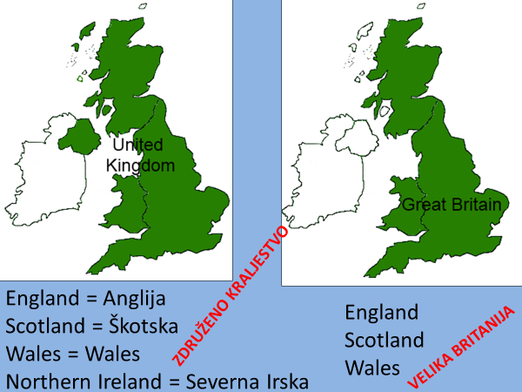

Oglej si posnetek o simbolih:

<https://www.youtube.com/watch?v=Fq4PeRFyAyg>

Poglej, kako je nastala zastava (imenuje se Union Jack):

<https://www.youtube.com/watch?v=tdHtaf0oKY0>

V zvezek napiši naslov **Great Britain (Velika Britanija)**. Prepiši vprašanja in nanja odgovori.

* Which is bigger: the United Kingdom or Great Britain?
* The UK consists of …countries. Name them.
* GB consists of …countries. Name them.
* Which country is in the United Kingdom but not in Great Britain?
* What is the capital of *England?*
* What is the capital of *Scotland*?
* What is the capital of *Wales*?
* What is the capital of *Northern Ireland*?
* What is the biggest city in *Great Britain*?
* The United Kingdom flag is called the Union Jack. Draw it.

Ponovi 😊:

<http://planeta42.com/geography/britishislespuzzle/>

<https://www.playgeography.com/games/countries-of-uk/>

