**Plan dela za 6.a razred: petek, 15.05.2020**

E-mail: [mateja.arh@oskoroskabela.si](mailto:mateja.arh@oskoroskabela.si)

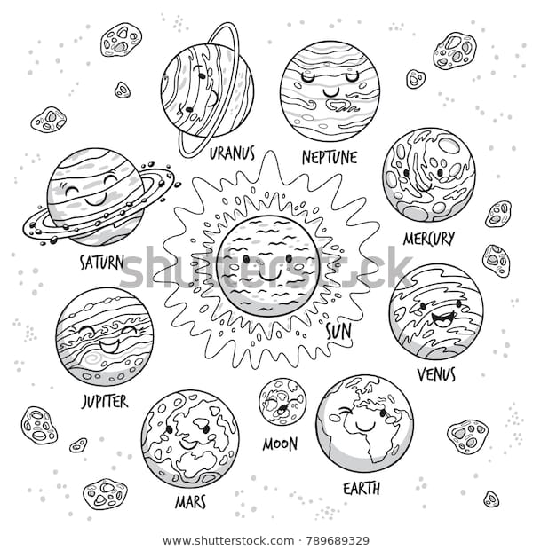**ENJOY THIS NIGHT!!!**

1. Do you know how many planets are there in our solar system?

2. Can you name them in Slovene? What about in English?

3. Now, please watch the video and remember the names of the planets in English.

<https://www.youtube.com/watch?v=aLOi2jJBai0> ( **the solar system video)**

4. Look at the picture and tell your parents which is the first, the second, the third, the fourth, the fifth, the sixth, the seventh, the eighth and the ninth planet from the Sun.



**5. Here you have some help!**



6. The universe is unknown and strange to us and so is the life of Pippi Longstocking. Before going to bed, watch the film about our hero Pippi.

<https://www.youtube.com/watch?v=xmcqNeTrHP4&t=565s> ( Pippi Longstocking film)

Enjoy in the film and sleep well!!!