Načrt dela za 8. abc / 1. Skupina: četrtek, 09.04.2020
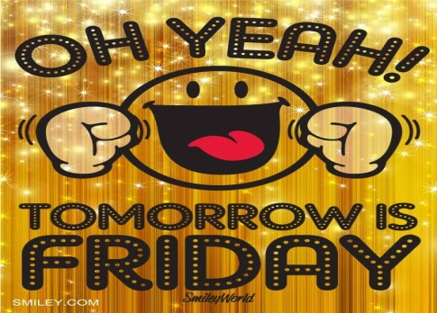 OSTANITE ZDRAVI!!!
Učiteljica Mateja Arh
E-mail: mateja.arh@oskoroskabela.si

- MISEL DNEVA: '' Zajček mali veselo skače naokrog, v košarici ima veliko dobrot. Tudi pri vas pozvoni in VESELE VELIKONOČNE PRAZNIKE VAM ŽELI!''' 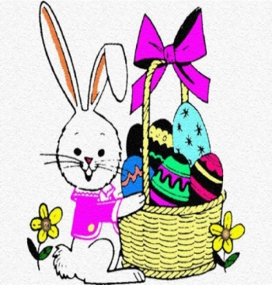
- REŠITVE: preveri in popravi. Nove besede zapiši v zvezek in prevedi!!!
• DZ str. 80/nal.46
HAIR COLOUR&STYLE: grey, fair ( svetel), long, short, curly, bald, black, dark, dreadlocks ( dredi), greasy ( masten), in plaits ( kite), parting ( prečka), ponytail ( čop), straight, wavy
EYE COLOUR: grey, black, dark
GENERAL APPEARANCE: cute ( ljubek), ugly, pretty ( čeden, lep), nice, good-looking, attractive, awesome ( osupljiv), beautiful, tanned ( zagorel), pale(bled)
BUILD(postava): thin, short, fat, slim, overweight, plump ( okrogel, debelušen), skinny( koščen, zelo suh), stocky(čokat)
OTHER: (teeth) braces ( zobni aparat), beard, beauty spot ( lepotno znamenje), freckles( pege), moustache, piercing, wrinkles (gube)
• DZ str. 80/ nal.47 ( nasprotja)
BUILD: tall – short
Fat – slim, thin, skinny
Slim – fat, overweight, plump
HAIR: short – long
Dark – fair, blond(e)
Straight – curly, wavy
GENERAL APPEARANCE: ugly – beautiful, pretty, good-looking, handsome, cute, attractive, awesome
Young – old
Attractive – ugly, unattractive
SKIN/COMPLECTION ( polt) : pale – tanned ( zagorela)

- NAREDI INTERVJU – THE INTERVIEW:
► vprašanja v spodnjem okvirju prepiši v zvezek; zastavi jih družinskemu članu ali prijatelju ter v zvezek zapiši tudi dobljen odgovor.
Ask your family member or a friend the following questions:
NAME: What's your name?
AGE: Are you old or young?
How old are you?
FIGURE: Are you tall or short?
How tall are you?
Are you slim or fat?
How much do you weigh?
EYES: What colour are your eyes?
HAIR: What is your hair like?
What colour hair have you got?

? : What do you like about yourself?

► vprašanja utrjuj z nalogo 45a + b , če je prejšnjič še nisi naredil/-a!
REŠITVE DZ nal.45a
EYE COLOUR: blue, brown
BUILD: tall, short
CLOTHES: sweater, coat, shoes, tights, skirt, sweatshirt, shorts, trainers
HAIR COLOUR&STYLE: brown, fair, fair-haired, long, in bunches, light brown
GENERAL APPEARANCE: pretty, glasses, braces, a bruise ( modrica), a cut ( ureznina), young
DZ str. 79/nal.45b
2 AGE How old is she?
3 HEIGHT ( višina) How tall is she?
4 WEIGHT ( teža) How much does she weigh?
5 HAIR COLOUR What colour is her hair?
6 EYE COLOUR What colour are her eyes?
7 CLOTHES What is/was she wearing?

HAPPY EASTER!!!

