Navodilo za TJA 9.ab - SRE 1. 4.

- Danes najprej preglej in popravi vaje DZ str. 78.

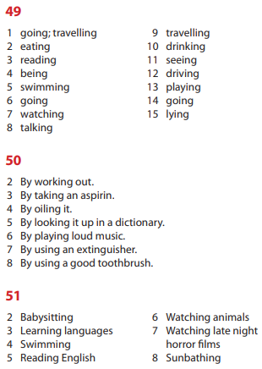

- V zvezek napiši naslov Gerund and prepositions in datum 1. 4.

- V zvezek zapiši vaje (18 stavkov) s povezave https://www.tolearnenglish.com/exercises/exercise-english-2/exercise-english-82507.php
Najprej reši online, nato spodaj klikni »Check my test«.
V zvezek prepiši cele stavke.
Podčrtaj predlog + gerund (1. primer: I'm thinking of learning either Italian or Spanish.).

- Za DN v zvezek zapiši 10 stavkov s povezave https://www.englisch-hilfen.de/en/exercises/structures/gerund_prepositions2.htm
Spet imaš možnost pregledati rešitve – v zvezek napiši cele, pravilne stavke.

Če slučajno povezave ne bi delale, imaš spodaj vse stavke. Vem, saj ne bi bilo treba …
1. I'm thinking learning either Italian or Spanish.
2. The noise prevented us sleeping.
3. It's no use crying !
4. Do you really mind leaving me ?
5. I don't succeed memorizing so many words !
6. Let me begin thanking you for the warm hospitality I received !
7. I can't help smiling whenever I think of it.
8. I've always been afraid to dive but one day, my friends talked me snorkelling and I have absolutely no regrets : it was an amazing experience !
9. She's not good managing her money !
10. He spent hours trying to find the solution.
11. For flight safety reasons, passengers are kindly requested to refrain using any portable.
12. It was no good being insistent.
13. He insisted being paid immediately.
14. This novel is worth reading.
15. They told me they suspected him plotting against me.
16. He didn't enjoy writing his books.
17. The boy was busy tidying his toys.
18. He apologized being late.¸

- I'm afraid my smartphone. (to lose)
- She's looking forward her brother. (to see)
- He is responsible the money. (to collect)
- She is used to bed late. (to go)
- He apologized late. (to be)
- Larry never worries friends. (to make)
- We are tired for the bus. (to wait)
- She insisted to her lawyer. (to talk)
- You should give your sister. (to bully)
- They are thinking to Italy. (to move)

