ČETRTEK, 21. 5. 2020

TJA 8 (skupina Ahačič: Anan, Ana, Matic, Gaj, Ermin, Kristjan, Anja, Ema, Matija, Jaka, Eldar, Anel)

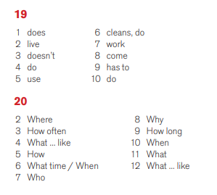
Preglej rešitve nalog v delovnem zvezku:
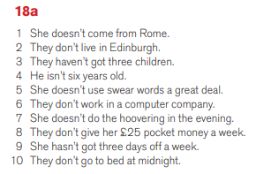
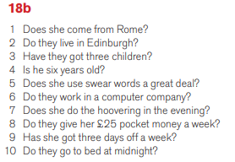
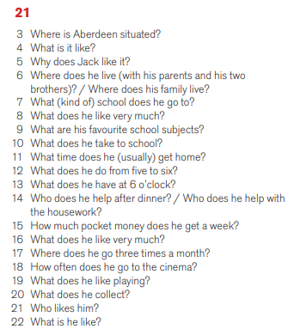

Zapomni si:

She has got a cat.
She hasn't got a cat.
Has she got a cat.

She has a shower.
She doesn't have a shower.
Does she have a shower?

Danes te čaka še nekaj nalog za ponovitev navadnega sedanjika (The Present Simple Tense). V zvezek napiši naslov Exercises.

Učni list lahko natisneš ali pa rešitve napišeš v zvezek. Rešitve mi pošlji!

THE PRESENT SIMPLE TENSE – EXERCISES

- Dopolni povedi s pravilno obliko glagola. Glej primer, ki je že rešen.

- We HAVE (have) dinner at seven o’clock.
- It _________________________ (work) very well.
- We always __________ (walk) home from school.
- She never __________ (drink) diet sodas.
- Do you __________ (like) to watch T.V.?
- He __________ ( not dance) very well.
- _________ she __________ (live) in California?
- Do you __________ (talk) to your brother every day?
- He __________ (take) vitamins every day.
- ___________ they __________ (travel) together?

2. Dopolni poved s pravilno obliko glagola in prislova iz oklepaja. Glej primer, ki je že rešen.

- Tina (sometimes, miss) SOMETIMES MISSES the bus to school.
- I (never, get up) _________________________ at 6.00.
- We (usually, have) _________________________ a holiday in August.
- Jim and Helen (often, go) _________________________ to the theatre.
- I (sometimes, sing) _________________________ in the shower.
- Pat (never, play) _________________________ football on Sunday.

3. Dopolni povedi. Glej primer, ki je že rešen.

- Mary (like, not) DOESN’T LIKE baseball.
- (wash, Peter) ______________________________ his face every morning?
- (watch, you) ______________________________ television every day?
- I (eat, not, often) ______________________________ fruit.
- (have, we) ______________________________ homework today?
- My father (work, not, usually) ______________________________ in the evening.
- (come, Bob) ______________________________ to school on his bike?
- Alex’s brothers (not, play) ______________________________ football on Sunday.
- (go, Jane, often) ______________________________ to the mountains?
- My friends (live, not) ______________________________ near my house.

