TOREK, 14. 4. 2020

TJA 8 (skupina Ahačič: Dino, Miha, Amanda, Laura, Nik, Ivana, Anže, Lorin, Ajda, Špela, Ana, Matevž K., Luka, Matevž P.P.)

Najprej preglejte nalogo v delovnem zvezku:
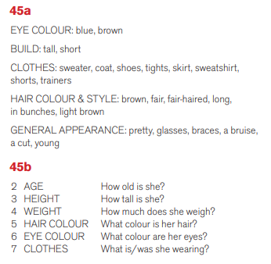

Še vedno opisujemo ljudi. Pogledali smo oblačila in zunanjost, danes se bomo naučili opisati še značaj.

CHARACTER (Značaj) (naslov v zvezku)
Zapis v zvezek:

Kadar opisujemo značaj človeka, uporabljamo vprašalnico
What are you like? (Kakšen si po značaju?)

What is he/she like? (Kakšen/Kakšna je po značaju?).

Naredi še spodnje naloge.

1. Prepiši pridevnike, ki opisujejo značaj osebe, in jih prevedi v slovenščino.

CALM /EASY GOING/ RELAXED | SERIOUS | UNTIDY/ MESSY | BOSSY
BRAVE | LAZY | RUDE | NOISY
POLITE | MEAN /SELFISH | CLEVER/ SMART/ INTELLIGENT / WISE | HARDWORKING
DISHONEST | SPORTY/ | FUNNY | NOSY
BORING | NERVOUS | QUIET | IMPATIENT
MEAN/CRUEL | CREATIVE | NICE/ FRIENDLY | HONEST
GENEROUS | SILLY | ORGANZED/ TIDY | SHY
2. Odgovori na vprašanja.
- What are you like?

- What do you like doing in your free time?

- What are you good at?

- What are you bad at?

- What are you frightened of?

- What can you do better this year?

- What’s your favourite class at school? Why?

- What type of music are you into? Why?

- Which famous person do you like? Why?

- What do you like and dislike about spring?

- What are you really looking forward to this year?

- What do you hope to do this year?

3. Kahoot challenge: kviz lahko rešiš do petka, 17. 4. 2020.
Personality adjectives

